

**LEARNING MANAGEMENT SYSTEM**

**A Project Report**

**SUBMITTED BY:**

**Saif Ali Khan**

In partial fulfilment for the award of the degree of

**BACHELOR OF COMPUTER APPLICATIONS (BCA)**

**AT**



**AMRAPALI INSTITUTE OF APPLIED SCIENCES**

**SHIKSHA NAGAR, HALDWANI-263139**

**(AFFILIATED TO KUMAUN UNIVERSITY, NAINITAL)**

**2019**

**Guide: Submitted By:**

**Dr.Nitin Deepak Saif Ali Khan**

**1661330071**

**ACKNOWLEDGEMENT**

The beatitude, bliss & euphoria that accompany the successful completion of any task would be incomplete without the expression of the appreciation of simple virtues to the people who made it possible. So with reverence, veneration and honour, I acknowledge whose guidance and encouragement has made successful in winding up this.

I owe a huge debt of thanks too many people with whom none of this would have been possible. I am thankful to **Dr.Nitin Deepak (Project Guide)** for valuable suggestions and enthusiastic interest during entire session.

Finally, I am very much grateful to the institute and all the faculty members. Without their personal attention and time to time help and care, it would not have been possible for me to complete this project.

I perceive at this opportunity as a big milestone in my career development. I will strive to use gained skill and Knowledge in the best possible way, and I will continue to work on their improvement, in order to attain desired career objectives. Hope to continue cooperation with all of you in future.

**DECLARATION**

I hereby declare that the project entitled “**Learning Management System”** submitted for the BCA degree is my original work and the project has not formed the basis for the award of any other degree, diploma, fellowship or any other similar titles.

**Place: Haldwani**

**Signature:**

**Date:**

|  |  |  |
| --- | --- | --- |
| **NAME** | **UNIVERSITY ROLL NUMBER** | **COURCE** |
| Saif Ali Khan | 1661330071 | BCA 6th sem |

**CERTIFICATE**

This is to certify that the project titled “**Learning Management system**” is the bona fide work carried out by **Saif Ali Khan, a student of BCA, Roll number: 1661330071, Amrapali Institute of Applied Sciences**, Haldwani affiliated to Kumaun University, Nainital, India during the academic year 2018-19, in partial fulfilment of the requirements for the award of the degree of Bachelor of Computer Applications and that the project has not formed the basis for the award previously of any other degree, diploma, fellowship or any other similar title.

**Place: Haldwani Signature of the Guide**

**Date:**

**Abstract**

The purpose of Learning Management system is to automate the existing manual system by the help of computerized equipment and full-fledged computer software, fulfilling their requirements, so that their valuable data/information can be stored for a longer period with easy accessing and manipulation of the same. The required software and hardware are easily available and easy to work with.

Learning Management system, as described above can lead to error free secure, reliable and fast management system. It can assist the user to concentrate on their other activities rather to concentrate on record keeping. Thus it will help organisation in better utilization of resources. The organization can maintain computerized records without redundant entries. That means one need not be distracted by information that is not relevant, while being able to reach the information.

The main aim is to automate its existing manual system by the help of computerized equipment and full-fledged computer software, fulfilling their requirements, so that their valuable data/information can be stored for a longer period with easy accessing and manipulation of the same. Basically the project describes how to manage data for good performance and better services for the clients.

**Synopsis**

Online learning has become more popular today, and Learning Management Systems help to administer, document, report, deliver, and track online training programs and educational cources. Many Universities use a LMS and corporate training departments often use these systems to automate training records, employee registration for training cource and to deliver online programs to employees as well.

A Learning Management System not only delivers the educational content, but also deals with cource, administration, registration, tracking reporting and more.

Some of the important dimensions of these systems include compliance training, online assessment, collaborative training, training resource managrment, student self-service and the management of continuing professional education.

Employing a Learning Management System has the ability to save instructors and companies, a significant amount of time, as it offers advance tracking and reporting, these systems make it easy to gain insights into the learning process of students or employees.

The systems help generate detailed reports, such as group reports, learning statistics, compliance reports, cource reports and more.

**Table of Contents**

|  |  |  |
| --- | --- | --- |
|  | Acknowledgement  Declaration of the Student |  |
|  | Certificate |  |
|  | Abstract |  |
|  | Synopsis |  |
|  |  |  |
| **1.** | **INTRODUCTION** | **1** |
|  | * 1. Problem Definition   2. Functionalities   3. Reports   4. Modules   5. Features   6. Hardware Requirements   7. Software Requirements | 1  2  2  2  2  3  3 |
|  |  |  |
| **2.** | **LITERATURE SURVEY** | **4** |
|  | 2.1 Existing System  2.2 Proposed System with objectives  2.3 Feasibility Study  2.3.1 Technical Feasibility  2.3.2 Behavioural Feasibility  2.3.3 Economical Feasibility  2.3.4 Operational Feasibility | 4  4  5  5  5  5  5 |
| **3.** | **SYSTEM ANALYSIS & DESIGN** | **6** |
|  | 3.1 Software Requirement Specification (SRS)  3.2 Data Flow Diagram  3.2.1 0 Level DFD  3.2.2 1 Level DFD  3.3 Entity Relationship Diagram  3.3.1 Conceptual ERD    3.4 Use Case Diagram  3.4.1 UML Admin Module  3.4.2 UML Teacher Module  3.4.3 UML Student Module  3.5 Data Dictionary  3.6 Design and test steps  3.7 Implementation and software specification testing  3.8 Pseudo Code & Algorithm  3.8.1 Methods for pseudo code  3.8.2 Algorithms for operations | 6  7  8  9  10  12  13  15  16  17  18  26  26  37  37  39 |
|  | **4. SNAPSHOTS** | **41** |
|  | **5. CONCLUSION** | **78** |
|  | **6. FUTURE SCOPE** | **79** |
|  | **7. LIMITATIONS** | **80** |
|  | **8. REFERENCES AND BIBLIOGRAPHY** | **81** |

1. **INTRODUCTION**

**1.1 Project Objective**

The main Objective of the project Learning Management System is to manage the details of Assignments, Students, Teacher and Question. It manages all the information about Assignments, Question, the project is totally built at administrative end and thus only the administrator is guaranteed the access. The purpose of the project is to build and application program to reduce the manual work of managing the Assignments, Students, Class, Teacher. It tracks all the details about Teacher, Quiz.

**1.2 Functionalities provides by Learning Management System are as follows:**

* Provides the searching facilities based on various factors. Such as Assignments, Teacher, Quiz, Question
* Learning Management System also manages the class details online for Question details, Assignments.
* It tracks all the information of Student, Class, Quiz, etc.
* Manage the information of student.
* Shows the information and description of the Assignment, Teacher.
* To increase efficiency of managing the Student, Assignment.
* Editing, adding, and updating of records is improved which result in proper resource management of Assignment data.
* Integration of all record of Question.
* Manage the information of Assignment

**1.3 Reports of Learning Management System**

* It generates the report of Student and Class.
* Provide filter reports on Teacher, Question.
* One can easily export PDF for the Assignment, Class, Question
* Application also provides excel exports for Students, Teacher, Question.
* One can also export the report into CSV format for Assignment and Questions.

**1.4 Modules of Learning Management System**

* Assignments Management Module: Used for managing the Assignment details.
* Question Module: Used for managing the details of Question.
* Class Module: Used for managing the details of Class.
* Student Management Module: Used for managing the information and details of the Student.
* Teacher Module: Used for managing the Teacher details
* Login Module: Used for managing the Login details.
* Users Module: Used for managing the users of the system.

**1.5 Features of Learning Management System**

* Creating and Changing issue at case.
* User accounts to control the access and maintains security.
* Robust database and back-end.
* It contains better storage capacity.
* Well-designed reports.
* Easy and fast retrieval of information.
* Works becomes very speedy.
* Easy to update information.

**1.6 Hardware Specification:**

Client Side:

* Dual core processor or above
* RAM 512MB or above
* HDD 512MB or above

Server Side:

* Intel i3 processor or above
* RAM 2GB or above
* HDD 2GB or above

**1.7 Software Specification:**

* Windows Operating System (Windows 7, 8, 8.1, 10)
* Php Wamp Server
* Database Mysql for Backend

**Server side-** An Apache web Server will accept all the requests from the client. A development database will be hosted locally (using Mysql) the production database is hosted centrally.

**MY-SQL (Backend)**

Mysql in July 2013,was the worlds second most widely used RDBMS, and the most widely used open-source client server model RDBMS. It is named after co-founder Michael widenius. The SQL abbreviation stands for Structured Query Language. The Mysql development project has made in source code available under the terms of the GNU General Public Licence, as well as under a variety of proprietary agreements.

**APACHE**

The Apache HTTP is web server software notable for playing a key role in the initial role of the World Wide Web. In 2009 it becomes the first web browser to surpass the 100 million website milestone. Apache is developed and maintained by open community of developers under the auspices of the Apache software foundation since April 1996 Apache has been the most popular HTTP Server Software in use.

**WAMP**

Wamp is a small and light Apache distribution containing the most common web development technologies in a single package. Its content small size and portability makes it the ideal tool for student developing and testing.

**2.** **LITERATURE SURVEY**

**2.1 EXISTING SYSTEM**

Currently, all the institute work is done manually. This results in lots of efforts & time wastage. Providing notes and assignments, taking attendance manually, keeping record of every institute detail like student, teacher records can be hectic & hard to manage.

**Limitations of existing system**

* Lack of security of data.
* More man power.
* Time consuming.
* Need manual calculators.
* No direct role for the higher officials.
* Consumes large volume of pare work.

**2.2 PROPOSED SYSTEM WITH OBJECTIVES**

* LMS enables educators to create their profile, manage their student’s attendance, assignments, provide online resources to students and manage subjects extend learning.
* It makes use of CMS( Content Management System) technologies to store course contents, subject details, assignments, attendance and records of students and teachers

The main objectives of developing the software of Learning Management System are as given below -:

1. The software is developed to overcome the limitation in managing record maintenance by manual approach.
2. The software is developed for smooth functioning.
3. To avoid delay in searching, updating or maintaining the records of students and teachers.
4. To handle a large amount of data that is a tedious job in case of manual system.
5. To increase record efficiency and reliability.
6. To reduce the efforts involved in processing.

**2.3 FEASIBILITY STUDY**

Feasibility study of Learning Management System includes consideration of all the possible ways to provide a solution to the given problem. The proposed system satisfies all the user requirements and is flexible enough so that future changes can be easily done based on the future upcoming requirements.

**2.3.1 Technical Feasibility**

Proper study of function, performance and constraints that may affect the ability to achieve an acceptable system has been done. For this feasibility study, I studied complete functionality to be provided in the system as described in the Software Requirement Specification (SRS), and checked if everything was possible using different type of frontend and backend platforms.

In technical feasibility, the following issues were taken into consideration :-

* Whether the required technology is available or not?
* Whether the required resources are available?

**2.3.2 Behavioural Feasibility**

In behavioural feasibility, I studied if the system is easy to operate, convenient in maintenance and effective in its working. The main focus was on how effectively the user will use the system.

**2.3.3 Economical Feasibility**

For Learning Management System, I decided that the technology is based on minimum possible cost factor.

* All hardware and software cost has to be borne by the organization.
* Overall I have estimated that the benefits the organization is going to receive from the proposed system will surely overcome the initial costs and the later on running cost for system.

**2.3.4 Operational Feasibility**

The proposed system is fully GUI based that is very user friendly and all inputs to be taken all self-explanatory even to a layman.

**3. SYSTEM ANALYSIS AND DESIGN**

**3.1 Software Requirement Specification**

The software requirement specification is produced at the culmination of the analysis task. The function and performance allocated to software as part of a system engineering are refined by establishing a complete information description, a detailed functional and behavioural description, an indication of performance requirements and design constraints, appropriate validation criteria, and other data pertinent to requirements.

**The Proposed System has the following requirements:**

* System needs store the information about the new entry of assignment.
* System need to help the internal staff to keep information of student and find them as per their various queries.
* System need to maintain quantity record.
* System need to keep the record of Teacher.
* System need to update and delete the record.
* System also needs to search the area.
* It also needs a security system to prevent data.

**Identification of need:**

The old manual system was suffering from a series of drawbacks. Since whole of the system was to be maintained with hands the process of keeping, maintaining and retrieving the information was very tedious and lengthy. The records were never used to be in a systematic order. There used to be lots of difficulties in associating any particular transaction with a particular context. If any information was to be found it was required to go through the different registers, documents there would be unnecessary consumption of time while entering and retrieving records. One more problem was that it was very difficult to find errors while entering the records. Once the records were entered it was very difficult to update these records.

The reason behind that is there is a lot of information to be maintained and have to keep in mind while running the business. For this reason, I have provided features. Present system is partially automated, actually present system, is quite laborious as one has to enter same information again and again at different places.

**3.2 DATA FLOW DIAGRAM**

A DFD also known as ‘bubble chart’ has the purpose of clarifying system requirements and identifying major transformations. It shows the flow of data through a system. It is a graphical tool because it presents a picture. The DFD may be partitioned into levels that represent increasing information flow and functional detail. Four simple notations are used to complete a DFD. These notations are given below:-

**DATA FLOW -** The data flow is used to describe the movement of information from one part of the system to another part. Flows represent data in motion. It is a pipe line through which information flows.

Data flow is represented by an arrow.

Data flow

**PROCESS -** A circle or bubble represents a process that transforms incoming data to outgoing data. Process shows a part of the system that transforms inputs to outputs.

**EXTERNAL ENTITY -** A square defines a source or destination of system data. External entities represent any entity that supplies or receive information from the system but is not a part of the system.

External Entity

**DATA STORE -** The data store represents a logical file. A logical file can represent either a data store symbol which can represent either a data structure or a physical file on disk. The data store is used to collect data at rest or a temporary repository of data. It is represented by open rectangle.

Data Store

**OUTPUT -** The output symbol is used when a hard copy is produced and the user of the copies cannot be clearly specified or there are several users of the output.

**3.2.1 LEVEL ‘0’ DFD FOR LEARNING MANAGEMENT SYSTEM**

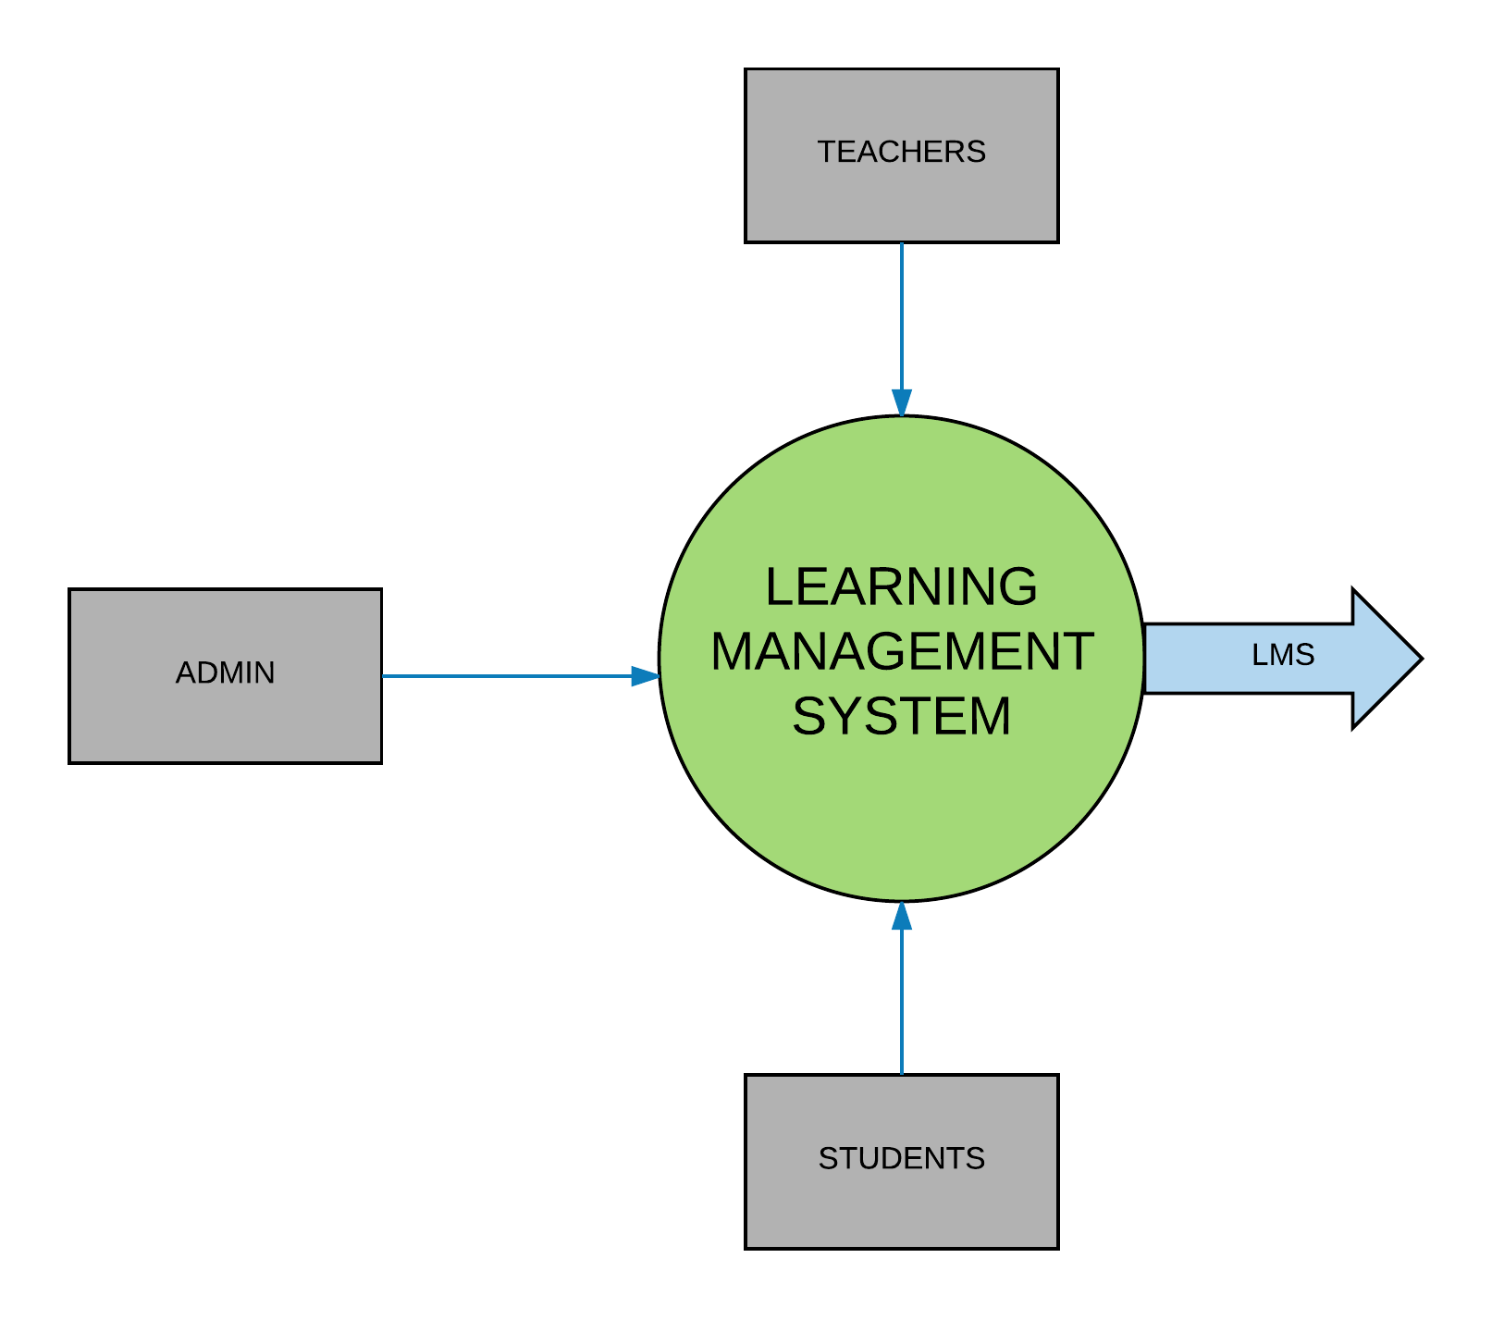

**3.2.2 LEVEL ‘1’ DFD FOR LEARNING MANAGEMENT SYSTEM**

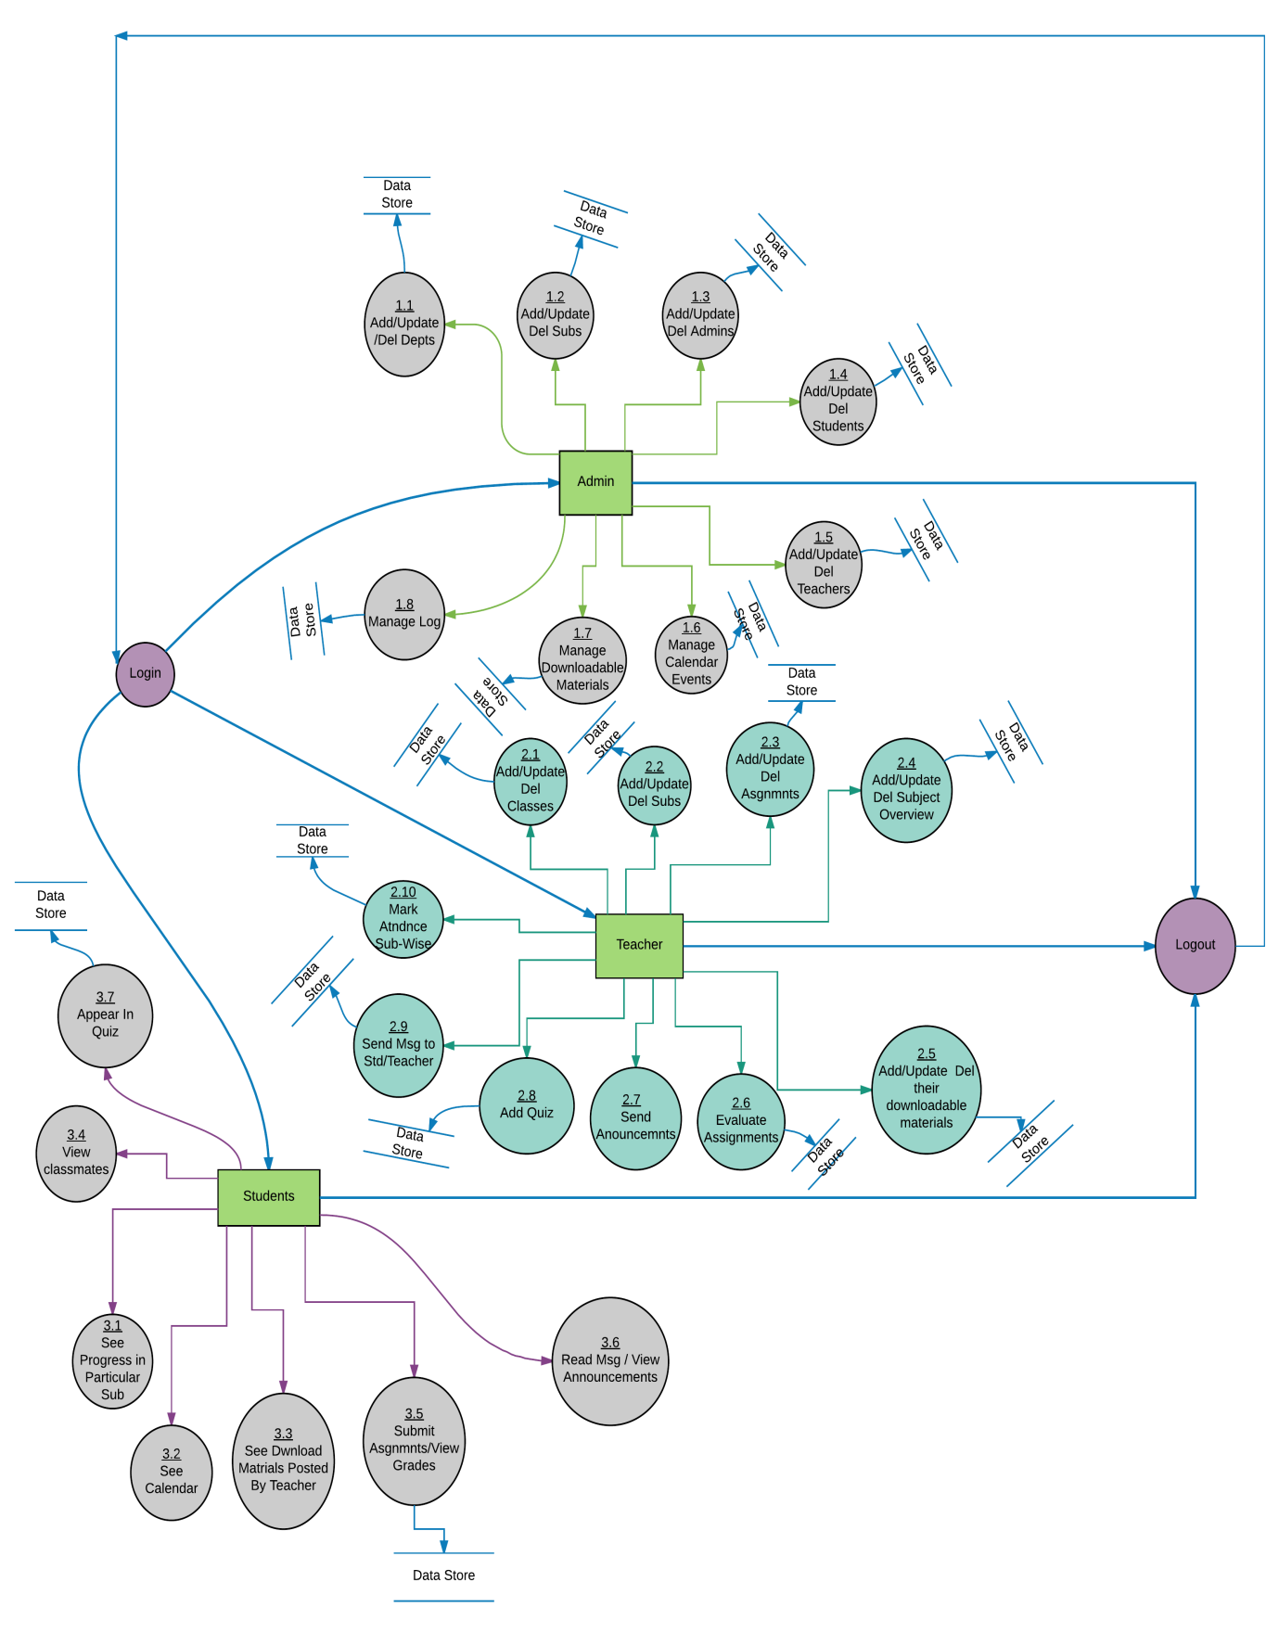

**3.3 ENTITY RELATIONSHIP DIAGRAM**

The entity relationship model was originally proposed by Peter Chen in 1976 as a way to unify the network and relational database views. The ER model is a conceptual data model that uses the real world entities and relationships. A basic component of the model is the entity relationship diagram which is used to visually represent data objects. Since Chen wrote his paper model has been extended and today it is commonly used for database design for the database designer, the utility of the ER model is:

* It maps well to the relational model. The constructs used in ER model can easily be transformed into relational tables.
* It is simple and easy to understand with a minimum training. Therefore, the model can be used by the database designer to communicate the design to the end user.
* In addition, the model can be used as a design plan by the database developer to implement a data model in specific database management software.

**Connectivity and Cardinality**

The basic types of connectivity for relations are- one-to-one, one-to-many and many-to-many. A one-to-one (1:1) relationship is when at most one instance of an entity. A is associated with one instance of entity B. For example, “employees in the company are each assigned their own office. For each employee there exist a unique office and for each office there exists a unique employee.

A one-to-many (1: n) relationships is when for one instance of entity A, there are zero, one, or many instances of entity B, but for one instance of entity A. An example of a 1: n relationship is

A department has many employees

Each employee is assigned to one department

A many-to-many (m: n) relationship, sometimes called non-specific, is when for one instance of entity A, there are zero, one, many instance of entity A. The connectivity of a relationship describes the mapping of associated.

## ER Notation

There is no standard for representing data objects in ER diagrams. Each modelling methodology uses its own notation. The original notation used by Chen is widely used in academics texts and journals but rarely seen in either CASE tools or publications by non-academics. Today, there are a number of notations used among the more common are Bachman, crow's foot, and IDEFIX. All notational styles represent entities as rectangular boxes and relationships as lines connecting boxes. Each style uses a special set of symbols to represent the cardinality of a connection. The notation used in this document is from Martin. The symbols used for the basic ER constructs are:

* **Entities** are represented by labelled rectangles. The label is the name of the entity. Entity names should be singular nouns.
* **Relationships** are represented by a solid line connecting two entities. The name of the relationship is written above the line. Relationship names should be verbs.
* **Attributes**, when included, are listed inside the entity rectangle. Attributes which are identifiers are underlined. Attribute names should be singular nouns.
* **Cardinality** of many is represented by a line ending in a crow's foot. If the crow's foot is omitted, the cardinality is one.
* **Existence** is represented by placing a circle or a perpendicular bar on the line. Mandatory existence is shown by the bar (looks like a 1) next to the entity for an instance is required. Optional existence is shown by placing a circle next to the entity that is optional.

**3.3.1 Conceptual Entity Relationship Diagram of Learning Management System**

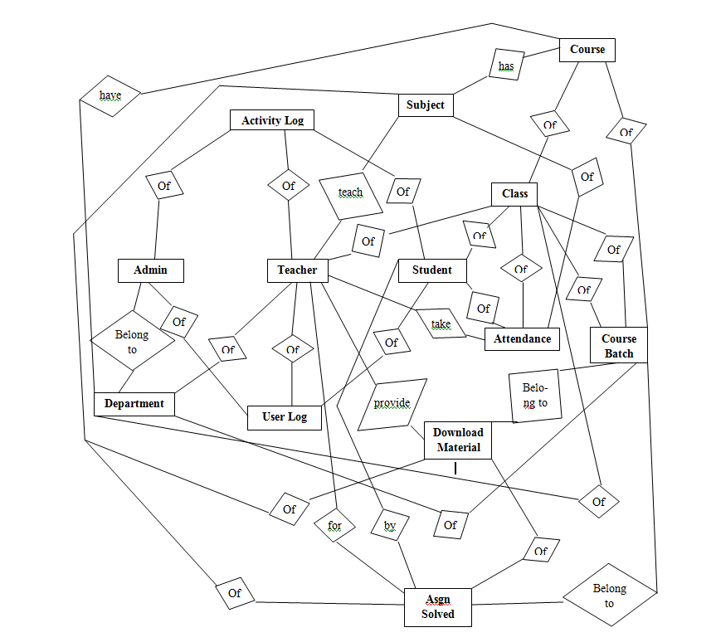

**3.4 USE CASE DIAGRAM**

**Unified Modelling Language (UML) Diagrams:**

**Actor:** A coherent set of roles that users of use cases play when interacting with the use cases.

**Use Case:** A description of sequence of actions, including variants, that a system performs that yields an observable result of value of an actor.

UML is a language for specifying, visualizing and documenting the system. This is the step while developing any product after analysis. The goal from this is to produce a model of the entities involved in the project which later need to be built. The representation of the entities that are to be used in the product being developed needs to be designed.

There are various kinds of methods in software design:

They are as follows:

* Use case Diagram
* Sequence Diagram
* Collaboration Diagram
* Activity Diagram
* State chat Diagram

**USE CASE DIAGRAMS:**

Use case diagrams model behaviour within a system and helps the developers understand of what the user require. The stick man represents an actor.

Use case diagram can be useful for getting an overall view of the system and clarifying what who can do and more importantly what they can’t do.

Use case diagram consists of use cases and actors and shows the interaction between the use case and actors.

* The purpose is to show the interactions between the use case and actor.
* To represent the system requirements from user’s perspective.
* An actor could be the end-user of the system or an external system.

A Use case is a description of set of sequence of actions. Graphically it is rendered as an ellipse with solid line including only its name. Use case diagram is a behavioral diagram that shows a set of use cases and actors and their relationship. It is an association between the use cases and actors. An actor represents a real-world object. Primary Actor– Sender, Secondary Actor Receiver.

**3.4.1 Use Case Diagram of Admin Module**

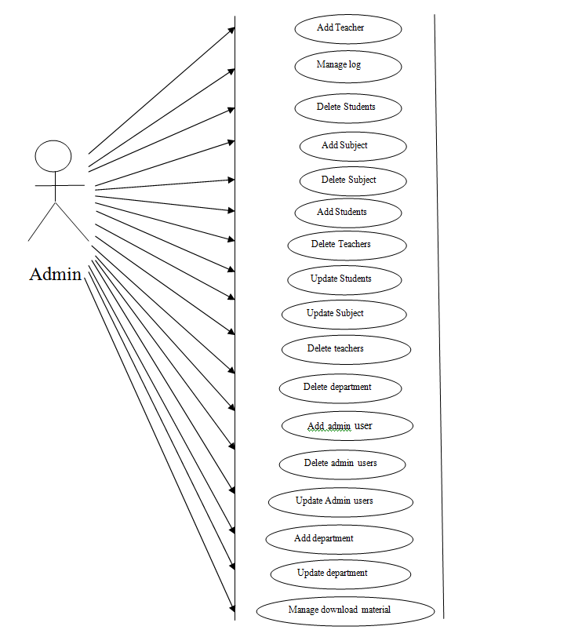

**3.4.2 Use case diagram of teacher module**

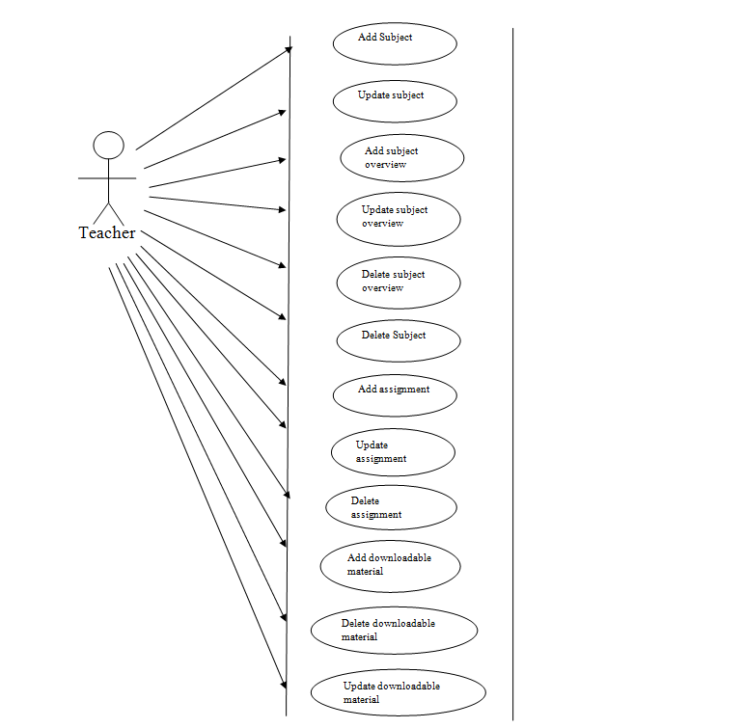

**3.4.3 Use Case diagram of student module**

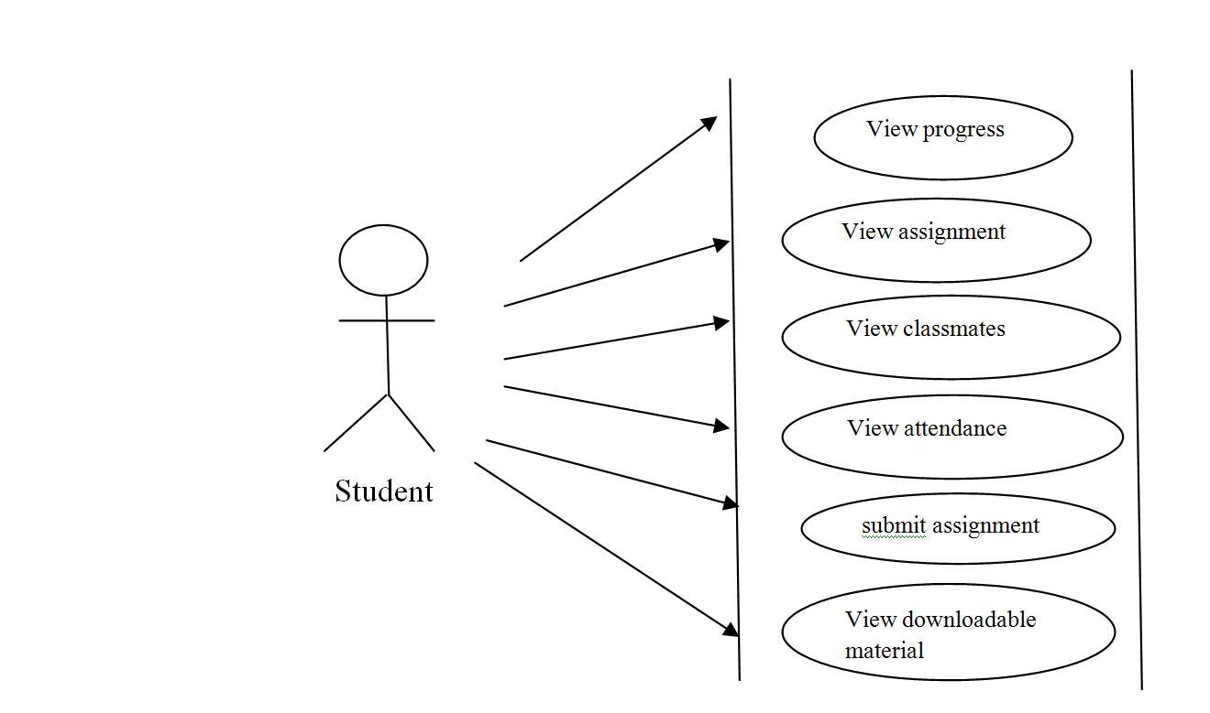

**3.5 Data Dictionary for Learning Management System (Physical ERD)**

Table: activity log

|  |  |  |  |  |
| --- | --- | --- | --- | --- |
| Name | Type | Nullable | Default | Extra |
| activity_log_id | bigint(10) | No | None | AI, P Key |
| std_id | bigint(20) | Yes | NULL | F Key |
| teacher_id | bigint(20) | Yes | NULL | F Key |
| admin_id | bigint(20) | Yes | NULL | F Key |
| date_time | timestamp | No | None |  |
| Action | varchar(100) | No | None |  |
| Authority | varchar(20) | No | admin |  |

Table: admin

|  |  |  |  |  |
| --- | --- | --- | --- | --- |
| Name | Type | Nullable | Default | Extra |
| admin _id | bigint(20) | No | None | AI, P Key |
| first_name | varchar(20) | No | None |  |
| last_name | varchar(20) | Yes | NULL |  |
| dept_id | bigint(20) | No | None | F Key |
| Username | varchar(20) | No | None |  |
| Password | varchar(15) | No | None |  |
| Thumbnail | varchar(100) | Yes | NULL |  |

Table: asgn_solved

|  |  |  |  |  |
| --- | --- | --- | --- | --- |
| Name | Type | Nullable | Default | Extra |
| asgn_solved_id | bigint(20) | No | None | AI, P Key |
| down_id | bigint(20) | No | None |  |
| upload_date | timestamp | No | None |  |
| std_id | bigint(20) | No | None |  |
| sub_id | bigint(20) | No | None |  |
| teacher_id | bigint(20) | No | None |  |
| course_batch_id | bigint(20) | No | None |  |
| Cmnt | varchar(100) | No | - |  |
| Marks | varchar(20) | No | TBA |  |
| file_path | varchar(100) | No | None |  |

Table: attendance

|  |  |  |  |  |
| --- | --- | --- | --- | --- |
| Name | Type | Nullable | Default | Extra |
| attendance_id | bigint(20) | No | None | AI, P Key |
| upload_date | date | No | None |  |
| upload _time | time | No | None |  |
| lect_attended | bigint(20) | No | None |  |
| lect_held | bigint(20) | No | None |  |
| sub_id | bigint(20) |  | None | F Key |
| teacher_id | bigint(20) | No | None | F Key |
| std_id | bigint(20) | No | None | F Key |
| class_type | varchar(50) | Yes | regular |  |
| sem_id | bigint (20) | No | TBA | F Key |
| class_id | bigint (20) | No | None | F Key |

Table: class

|  |  |  |  |  |
| --- | --- | --- | --- | --- |
| Name | Type | Nullable | Default | Extra |
| class_id | bigint(20) | No | None | AI, P Key |
| course_batch_id | bigint(20) | No | None | F Key |
| Section | varchar(1) | Yes | NULL |  |
| dept_id | bigint(20) | Yes | NULL | F Key |
| teacher_id | bigint(20) | Yes | NULL | F Key |
| sem_id | bigint (20) | Yes | NULL | F Key |
| course_id | bigint (20) | Yes | NULL | F Key |
| Session | varchar(20) | Yes | NULL |  |

Table: course

|  |  |  |  |  |
| --- | --- | --- | --- | --- |
| Name | Type | Nullable | Default | Extra |
| course_id | bigint(20) | No | None | AI, P Key |
| course_name | varchar(10) | No | None |  |
| dept_id | bigint(20) | No | None | F Key |

Table: course_batch

|  |  |  |  |  |
| --- | --- | --- | --- | --- |
| Name | Type | Nullable | Default | Extra |
| course_batch_id | bigint(20) | No | None | AI, P Key |
| class_ batch | varchar(15) | No | None |  |
| course_id | bigint(20) | No | None | F Key |
| dept_id | bigint(20) | No | None | F Key |

Table: department

|  |  |  |  |  |
| --- | --- | --- | --- | --- |
| Name | Type | Nullable | Default | Extra |
| dept_id | bigint(20) | No | None | AI, P Key |
| dept_name | varchar(10) | No | None |  |
| Abbr | varchar(100) | Yes | NULL |  |
| Dir | varchar(40) | No | None |  |

Table: download materials

|  |  |  |  |  |
| --- | --- | --- | --- | --- |
| Name | Type | Nullable | Default | Extra |
| down_id | bigint(20) | No | None | AI, P Key |
| teacher_id | bigint(20) | No | None | F Key |
| sub_id | bigint(20) | No | None | F Key |
| course_batch_id | bigint(20) | No | None | F Key |
| upload_date | timestamp | No | None |  |
| file_name | varchar(100) | Yes | NULL |  |
| Description | varchar(200) | Yes | NULL |  |
| file_path | varchar(200) | No | None |  |

Table: semester

|  |  |  |  |  |
| --- | --- | --- | --- | --- |
| Name | Type | Nullable | Default | Extra |
| sem_id | bigint(20) | No | None | AI, P Key |
| sem_no | varchar(7) | No | None |  |
| Year | varchar(7) | No | None |  |

Table: student

|  |  |  |  |  |
| --- | --- | --- | --- | --- |
| Name | Type | Nullable | Default | Extra |
| std_id | bigint(20) | No | None | AI, P Key |
| first_name | varchar(20) | No | None |  |
| last_name | varchar(20) | No | None |  |
| gender | varchar(6) | No | NULL |  |
| Email | varchar(50) | No | NULL |  |
| Dob | date | No | NULL |  |
| contact | bigint(20) | No | NULL |  |
| roll_no | bigint(20) | No | NULL |  |
| card_id | bigint(20) | No | None |  |
| class_id | bigint(20) | Yes | NULL | F Key |
| username | varchar(20) | Yes | NULL |  |
| password | varchar(15) | Yes | NULL |  |
| Status | varchar(50) | Yes | Deactivated |  |
| thumbnail | varchar(80) | Yes | NULL |  |

Table: subject

|  |  |  |  |  |
| --- | --- | --- | --- | --- |
| Name | Type | Nullable | Default | Extra |
| sub_id | bigint(20) | No | None | AI, P Key |
| sub_name | varchar(40) | No | None |  |
| teacher_id | bigint(20) | No | None | F Key |
| overview | varchar(10000) | Yes | - |  |
| sub_code | varchar(15) | No | None |  |
| Units | bigint(20) | Yes | NULL |  |
| sem_id | bigint(20) | Yes | NULL | F Key |
| course_id | bigint(20) | No | None | F Key |

Table: student

|  |  |  |  |  |
| --- | --- | --- | --- | --- |
| Name | Type | Nullable | Default | Extra |
| teacher_id | bigint(20) | No | None | AI, P Key |
| first_name | varchar(20) | No | None |  |
| last_name | varchar(20) | No | None |  |
| dept_id | bigint(20) | No | None | F Key |
| Email | varchar(50) | Yes | NULL |  |
| Dob | date | Yes | NULL |  |
| contact | bigint(20) | Yes | NULL |  |
| gender | varchar (10) | Yes | NULL |  |
| card_id | varchar (10) | No | None |  |
| username | varchar(20) | Yes | NULL |  |
| password | varchar(15) | Yes | NULL |  |
| Status | varchar(20) | Yes | Deactivated |  |
| thumbnail | varchar(80) | Yes | NULL |  |

Table: user_log

|  |  |  |  |  |
| --- | --- | --- | --- | --- |
| Name | Type | Nullable | Default | Extra |
| user_log_id | bigint(20) | No | None | AI, P Key |
| std_id | bigint(20) | Yes | NULL | F Key |
| admin_id | bigint(20) | Yes | NULL | F Key |
| teacher_id | bigint(20) | Yes | NULL | F Key |
| login_date_time | Timestamp | Yes | NULL |  |
| logout_date_time | Timestamp | Yes | NULL |  |
| authority | varchar (20) | No | None |  |

**3.6 DESIGN AND TEST STEPS**

## Validation Testing

The process of evaluating software during the development process or at the end of the development process to determine whether it satisfies specified business requirements.

**3.7 Implementation and software specification testing**

**Detailed design of Implementation**

This phase of the systems development life cycle refines hardware and software specifications, establishes programming plans, train users and implements extensive testing procedures, to evaluate design and operating specifications and/or provide the basis for further modification.

**Technical design**

This activity builds upon specification produced during new system designs, adding detailed technical specification and documentation.

**Test Specifications and planning**

This activity builds upon specifications for individual modules, program, job streams, subsystems, and for the systems as whole.

**Programming and Testing**

This activity encompasses actual development, writing and testing of program units or modules.

**Test Cases**

A test case has components that describe input, action and an expected response, in order to determine if a feature of an application is working correctly.

Here are the manual testing cases done by me :

1. LOGIN

|  |
| --- |
| TEST CASE ID: T1 |

|  |  |
| --- | --- |
| SECTION-1  (BEFORE EXECUTION) | SECTION-2  (AFTER EXECUTION) |
| PURPOSE: Used to provide way to enter through user id and password | EXECUTION HISTORY:  None |
| PRECONDITION: The user must visit before this use case begin | RESULT: After successful login, the actor will enter the dashboard of learning management system. |
| INPUTS: Username, Password | IF FAILS, ANY POSSIBLE REASON: Username or password is invalid |
| EXPECTED OUTPUTS: User gets login to the system with valid id and password | OTHER OBSERVATIONS: No |
| POST CONDITIONS: If the event is successful, the actor is logged into the system, else, the system state is unchanged. | SUGGESTIONS: Look for the case sensitivity while entering the username and password. |

|  |  |  |  |  |  |  |
| --- | --- | --- | --- | --- | --- | --- |
| **Test case ID** | **Test Scenario** | **Test Steps** | **Test Data** | **Expected Results** | **Actual Results** | **Pass/Fail** |
| T01 | Check user login with valid data | 1. Go to application of online Learning Management System 2. Enter User ID 3. Enter Password 4. Submit | Email:nikita.joshi@gmail.com  Passsword:nikita.joshi | User should login to application | As expected | Pass |
| T02 | Check user login with invalid data | 1. Go to application of online Learning Management System 2. Enter User ID 3. Enter Password 4. Submit | Email: [suman@gmail.com](mailto:suman@gmail.com)  Password: suman123 | User should not login to application | As expected | Pass |

1. SIGN UP

|  |
| --- |
| TEST CASE ID: T2 |

|  |  |
| --- | --- |
| SECTION-1  (BEFORE EXECUTION) | SECTION-2  (AFTER EXECUTION) |
| PURPOSE: Used to provide way to enter in dashboard | EXECUTION HISTORY:  None |
| PRECONDITION: The user must visit LMS page before this case begin | RESULT: After successful login, the actor will registered into the system |
| INPUTS: Username, Password | IF FAILS, ANY POSSIBLE REASON: Username or password is invalid |
| EXPECTED OUTPUTS: User gets login to the system with valid id and password | OTHER OBSERVATIONS: No |
| POST CONDITIONS: If the event is successful, the actor is logged into the system, else, the system state is unchanged. | SUGGESTIONS: Look for the case sensitivity while entering the username and password. |

|  |  |  |  |  |  |  |
| --- | --- | --- | --- | --- | --- | --- |
| **Test case ID** | **Test Scenario** | **Test Steps** | **Test Data** | **Expected Results** | **Actual Results** | **Pass/Fail** |
| T01 | Check user login with valid data | 1. Go to application of online Learning Management System 2. Enter all registration credentials 3. Enter Password 4. Sign Up | Email:nikita.joshi@gmail.com  Passsword:nikita.joshi | User should register to the application | As expected | Pass |
| T02 | Check user login with invalid data | 1. Go to application of online Learning Management System 2. Enter all registration credentials 3. Enter Password 4. Sign Up | Email: [suman@gmail.com](mailto:suman@gmail.com)  Password: suman123 | User should not register to the application | As expected | Pass |

3.CHANGE PASSWORD

|  |
| --- |
| TEST CASE ID: T3 |

|  |  |
| --- | --- |
| SECTION-1  (BEFORE EXECUTION) | SECTION-2  (AFTER EXECUTION) |
| PURPOSE: Used to provide way to change password | EXECUTION HISTORY:  None |
| PRECONDITION: The user must login in LMS page before this case begin | RESULT: After successful change submission, the actor will have a changed password for the respective user id. |
| INPUTS: Username, Password | IF FAILS, ANY POSSIBLE REASON: Username or password is invalid |
| EXPECTED OUTPUTS: User gets a new changed password | OTHER OBSERVATIONS: No |
| POST CONDITIONS: If the event is successful, the actor’s changed the current password with the new password, else, the system state is unchanged. | SUGGESTIONS: Look for the case sensitivity while entering the username and password. |

|  |  |  |  |  |  |  |
| --- | --- | --- | --- | --- | --- | --- |
| **Test case ID** | **Test Scenario** | **Test Steps** | **Test Data** | **Expected Results** | **Actual Results** | **Pass/Fail** |
| T01 | Check user login with valid data | 1. Go to application of online Learning Management System 2. Login in LMS 3. Choose Edit profile 4. Change Password 5. Submit | Email:nikita.joshi@gmail.com  Passsword:nikita.joshi | User should change the password aassociated with username of the application | As expected | Pass |
| T02 | Check user login with invalid data | 1. Go to application of online Learning Management System 2. Login in LMS 3. Choose Edit profile 4. Change Password 5. Submit | Email: [suman@gmail.com](mailto:suman@gmail.com)  Password: suman123 | User should not change the password aassociated with username of the application | As expected | Pass |

1. TAKE ATTENDANCE

|  |
| --- |
| TEST CASE ID: T4 |

|  |  |
| --- | --- |
| SECTION-1  (BEFORE EXECUTION) | SECTION-2  (AFTER EXECUTION) |
| PURPOSE: Used to provide way to take attendance | EXECUTION HISTORY:  None |
| PRECONDITION: The user must login in LMS page before this case begin | RESULT: After successful data submission, the actor has accomplished the event of marking the students attendance |
| INPUTS: Username, Password | IF FAILS, ANY POSSIBLE REASON: Username or password is invalid |
| EXPECTED OUTPUTS: User gets marked attendance | OTHER OBSERVATIONS: No |
| POST CONDITIONS: If the event is successful, the actor has accomplished the event of marking the students attendance, else, the system state is unchanged. | SUGGESTIONS: Look for the case sensitivity while entering the username and password. |

|  |  |  |  |  |  |  |
| --- | --- | --- | --- | --- | --- | --- |
| **Test case ID** | **Test Scenario** | **Test Steps** | **Test Data** | **Expected Results** | **Actual Results** | **Pass/Fail** |
| T01 | Check user login with valid data | 1. Go to application of online Learning Management System 2. Login in LMS 3. Choose Mark attendance 4. Select date, class and section 5. Submit | Email:nikita.joshi@gmail.com  Passsword:nikita.joshi | User should be able to mark the attendance of student in the application | As expected | Pass |
| T02 | Check user login with invalid data | 1. Go to application of online Learning Management System 2. Login in LMS 3. Choose Mark Attendance 4. Select date, class, and section 5. Submit | Email: [suman@gmail.com](mailto:suman@gmail.com)  Password: suman123 | User should be able to mark the attendance of student in the application | As expected | Pass |

1. EDIT PROFILE

|  |
| --- |
| TEST CASE ID: T5 |

|  |  |
| --- | --- |
| SECTION-1  (BEFORE EXECUTION) | SECTION-2  (AFTER EXECUTION) |
| PURPOSE: Used to provide way to edit profile of the actor | EXECUTION HISTORY:  None |
| PRECONDITION: The user must login in LMS page before this case begin | RESULT: After successful data submission, the event of making amendments in user profile is successful |
| INPUTS: Username, Password | IF FAILS, ANY POSSIBLE REASON: Username or password is invalid |
| EXPECTED OUTPUTS: User gets amendments in user profile | OTHER OBSERVATIONS: No |
| POST CONDITIONS: If the event is successful, the actor has accomplished the event of making amendments in user profile, else, the system state is unchanged. | SUGGESTIONS: Look for the case sensitivity while entering the username and password. |

|  |  |  |  |  |  |  |
| --- | --- | --- | --- | --- | --- | --- |
| **Test case ID** | **Test Scenario** | **Test Steps** | **Test Data** | **Expected Results** | **Actual Results** | **Pass/Fail** |
| T01 | Check user login with valid data | 1. Go to application of online Learning Management System 2. Login in LMS 3. Choose Edit profile 4. Select chages 5. Submit | Email:nikita.joshi@gmail.com  Passsword:nikita.joshi | User should be able to make amendments in user profile in the application | As expected | Pass |
| T02 | Check user login with invalid data | 1. Go to application of online Learning Management System 2. Login in LMS 3. Choose Edit profile 4. Select chages 5. Submit | Email: [suman@gmail.com](mailto:suman@gmail.com)  Password: suman123 | User should not be able to make amendments in user profile in the application | As expected | Pass |

**Acceptance test**

A final procedure review to demonstrate a system and secure user approval before a system becomes operational.

**Post Implementation Review**

A review conducted after a new system has been in operation for some time, to evaluate actual system performance against original expectations and projections for cost-benefit improvements. Also identifies maintenance project to enhance or improves the system.

* 1. **Pseudo Code & Algorithm**

**3.8.1 Methods for Pseudo Code:**

Pseudo-code is

* Intuitive/informal notational system
* Good starting point for representing algorithms in any high-level programming language

Pseudo code is a kind of structured English for describing algorithms. It allows the designer to focus on the logic of the algorithm without being distracted by details of language syntax.  At the same time, the pseudo code needs to be complete.  It describes the entire logic of the algorithm so that implementation becomes a rote mechanical task of translating line by line into source code.

In general, the vocabulary used in the pseudo code should be the vocabulary of the problem domain, not of the implementation domain.  The pseudo code is a narrative for someone who knows the requirements (problem domain) and is trying to learn how the solution is organized.

The "structured" part of pseudo code is a notation for representing six specific structured programming constructs: SEQUENCE, WHILE, IF-THEN-ELSE, REPEAT-UNTIL, FOR, and CASE. Each of these constructs can be embedded inside any other construct. These construct represent the logic, or flow of control in an algorithm.

It has been proven that three basic constructs for flow of control are sufficient to implement any "proper" algorithm.

**SEQUENCE** is a linear progression where one task is performed sequentially after another.

**WHILE** is a loop (repetition) with a simple conditional test at its beginning.

**IF-THEN-ELSE** is a decision (selection) in which a choice is made between two alternative courses of action.

Although these constructs are sufficient, it is often useful to include three more constructs:

**REPEAT-UNTIL** is a loop with a simple conditional test at the bottom.

**CASE** is a multiway branch (decision) based on the value of an expression. CASE is a generalization of IF-THEN-ELSE.

**FOR** is a "counting" loop.

**3.8.2 Algorithm for Operations:**

**FOR ADMINS**

Step1: Start.

Step2: First of all, admin will login.

Step 4: Use side nav-bar to select the desired option.

Step 5: Navigate to selected page.

Step 6: Manage his respective class, subject & its download materials and assignments, etc. under teacher privilege a/c to his choice.

Step 7: Repeat Step 4 – 6 until teacher logouts.

Step 8: End

**FOR TEACHERS**

Step1: Start.

Step2: First of all teacher will login.

IF username & password = true THEN

Login successful (open teacher dashboard)

ELSE

Display (Invalid Credentials!!!)

Repeat Step 2

ENDIF

Step 3: Login successfully done.

Step 4: Use side nav-bar to select the desired option.

Step 5: Navigate to selected page.

Step 6: Manage his respective class, subject & its download materials and assignments, etc under teacher privilege a/c to his choice.

Step 7: Repeat Step 4 – 6 until teacher logouts.

Step 8: End

**FOR STUDENTS**

Step1 - Start.

Step2 - First of all student will login.

IF username & password = true THEN

Login successful (open student dashboard)

ELSE

Display (Invalid Credentials!!!)

Repeat Step 2

ENDIF

Step 3: Login successfully done.

Step 4: Use side nav-bar to select the desired option.

Step 5: Navigate to selected page.

Step 6: View his class, subjects, upload/download assignments, download study materials, view his attendance, etc under student privilege a/c to his choice.

Step 7: Repeat Step 4 – 6 until student logouts.

Step 8: End.

**4. SNAPSHOTS**

**Index page of LMS**

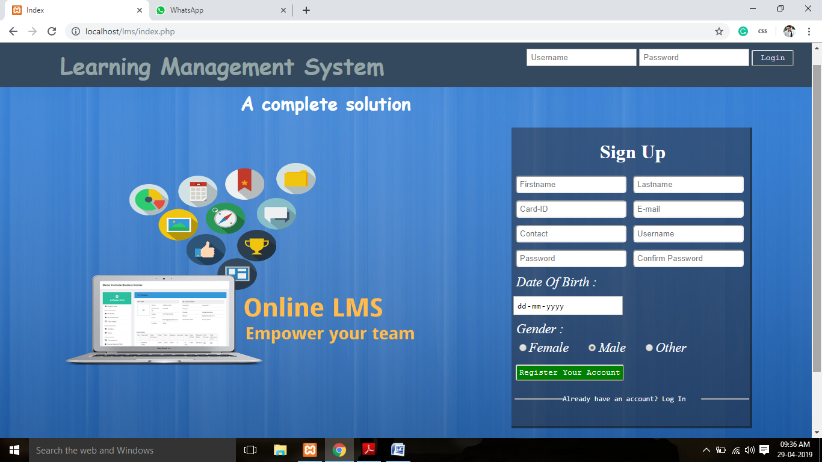

**Sign Up- Successful on successful user registration**

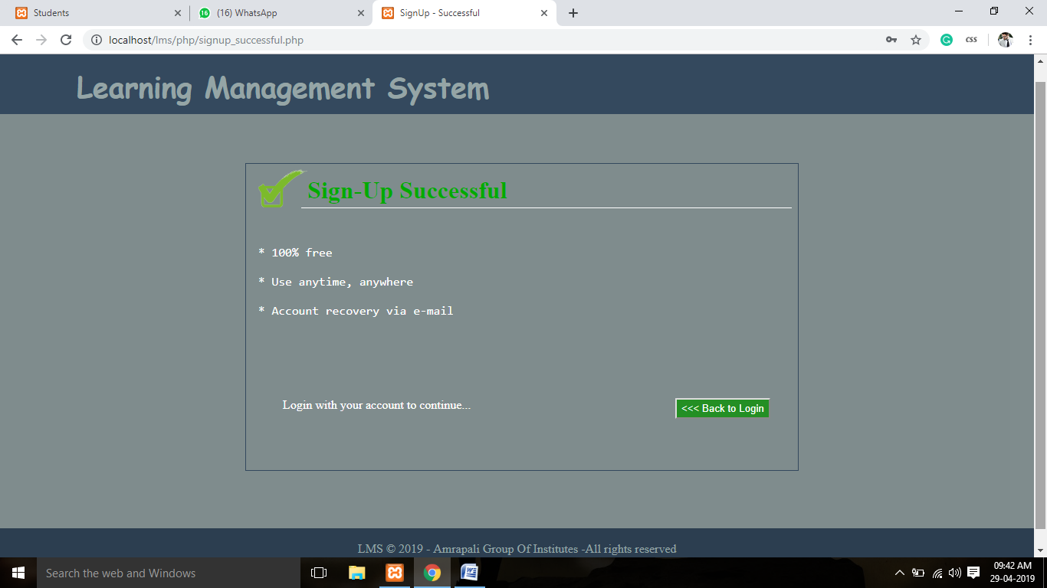

**Sign Up- Unsuccessful in case of failed user registration**

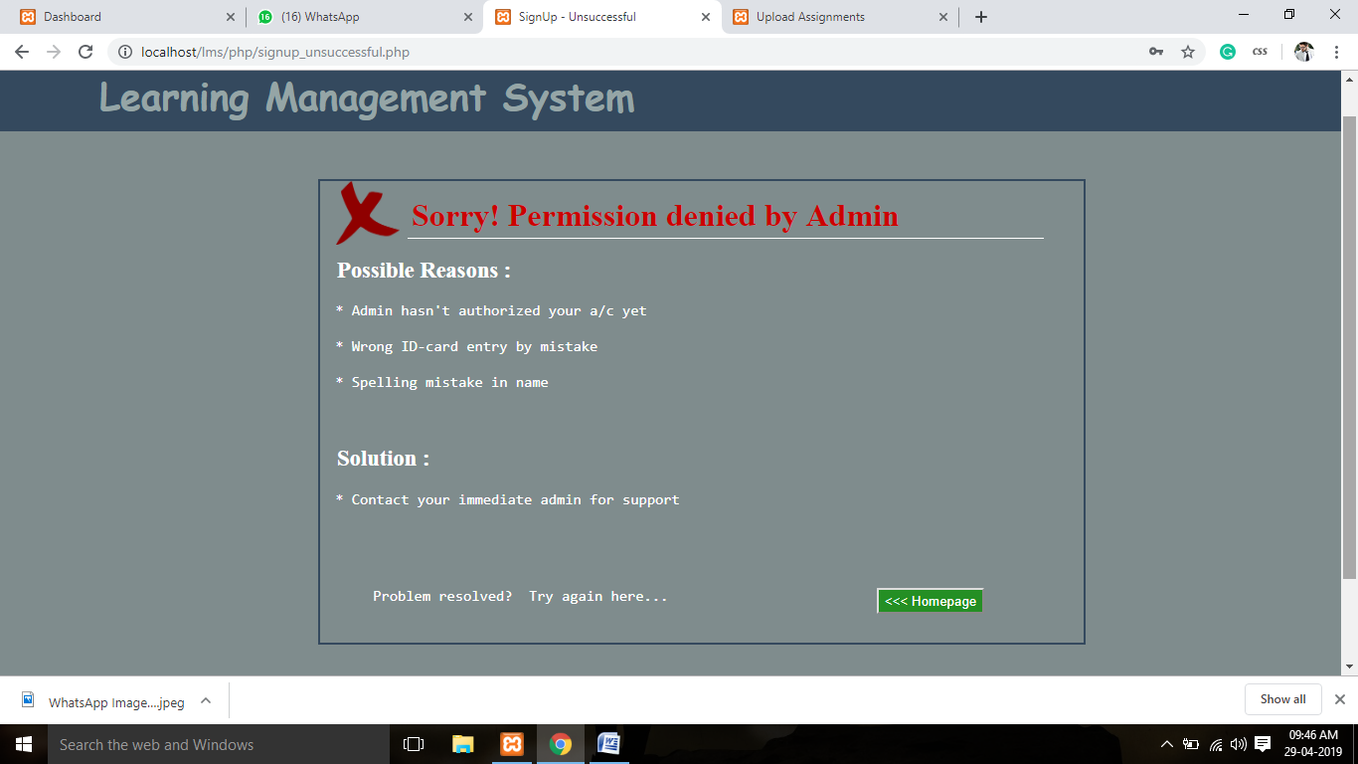

**Admin Login page**

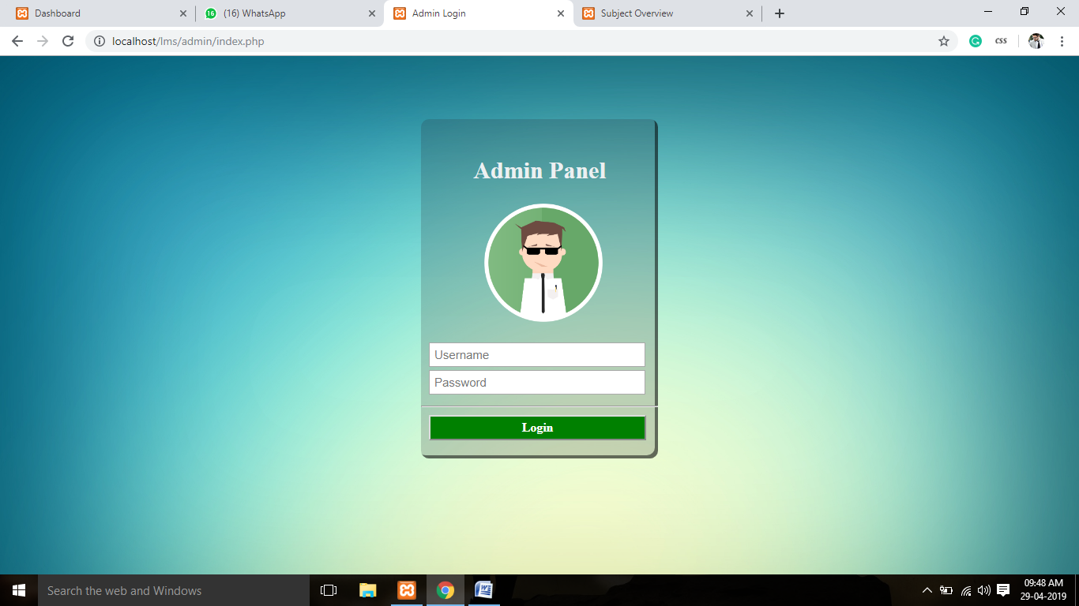

**Admin Dashboard – Shows Information Summary**

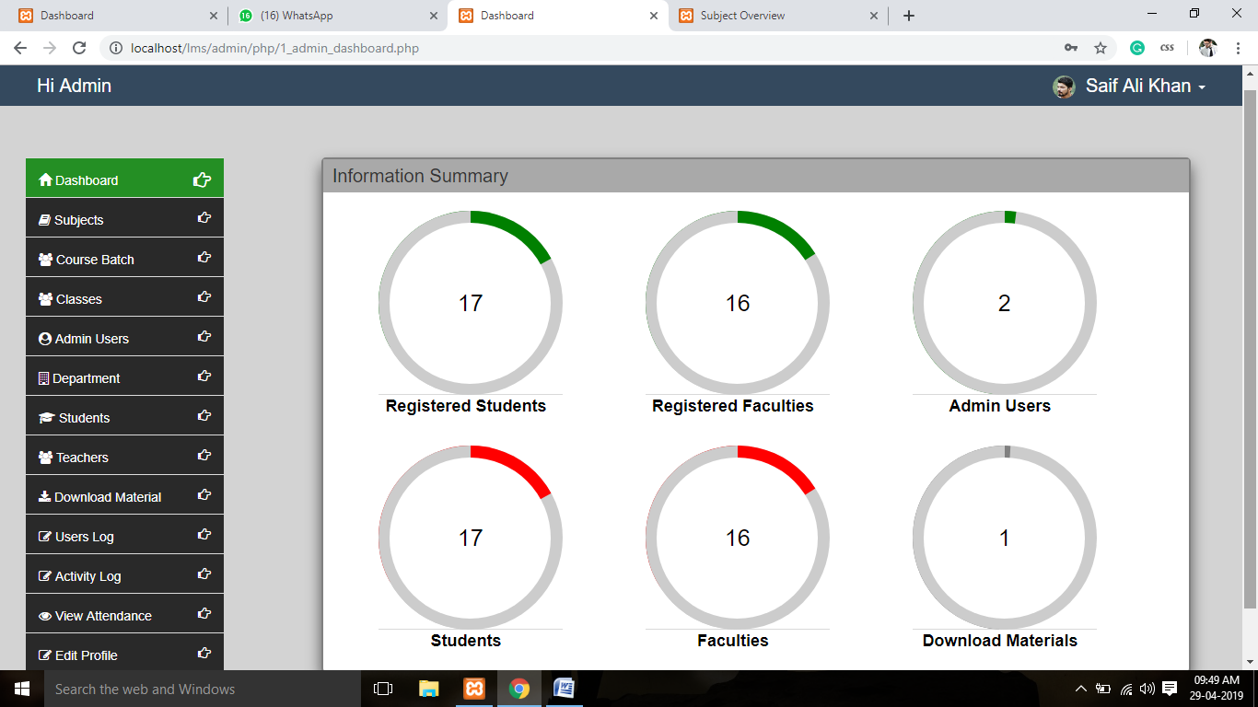

**Subjects – Manage Departmental Subjects**

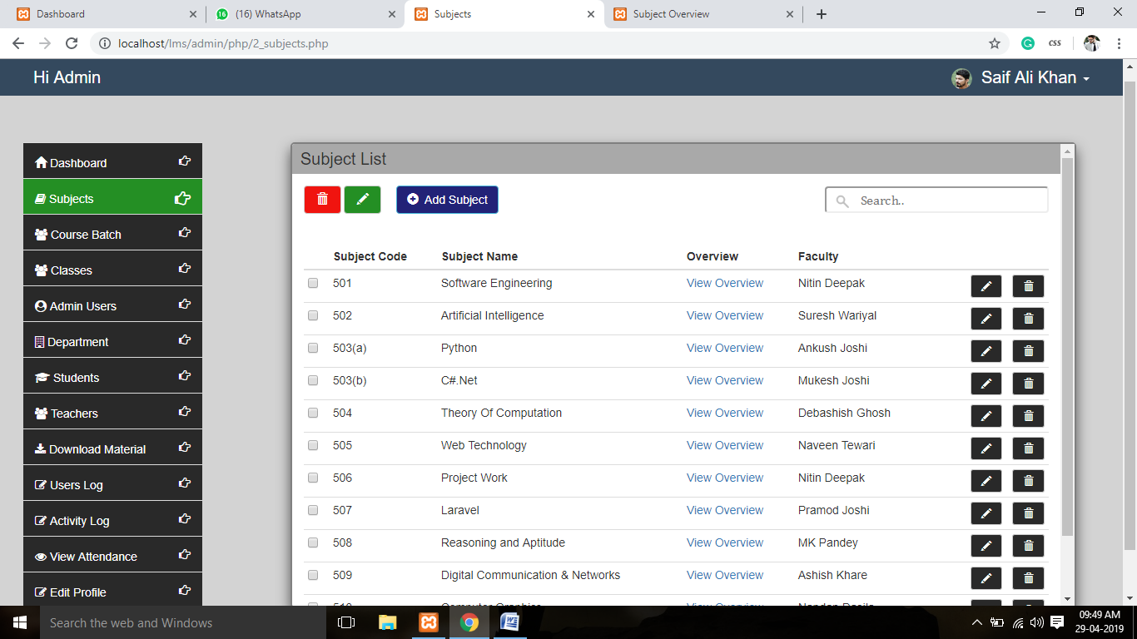

**Course Batch – Manage Departmental Batches**

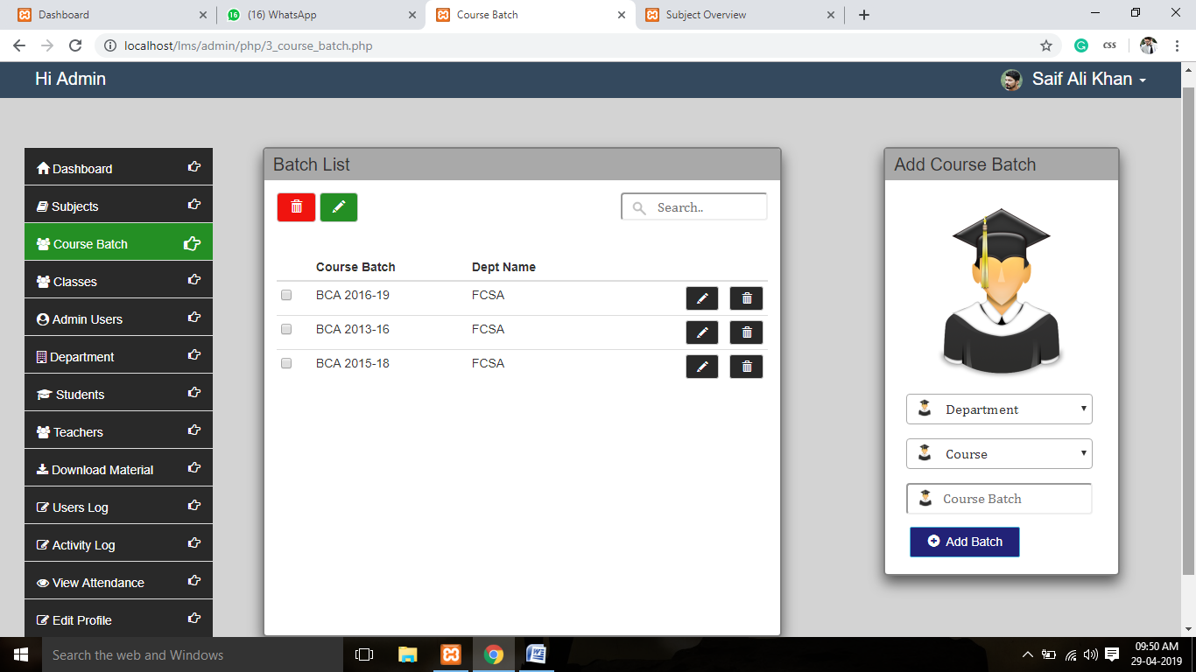

**Classes – Manage Departmental Classes**

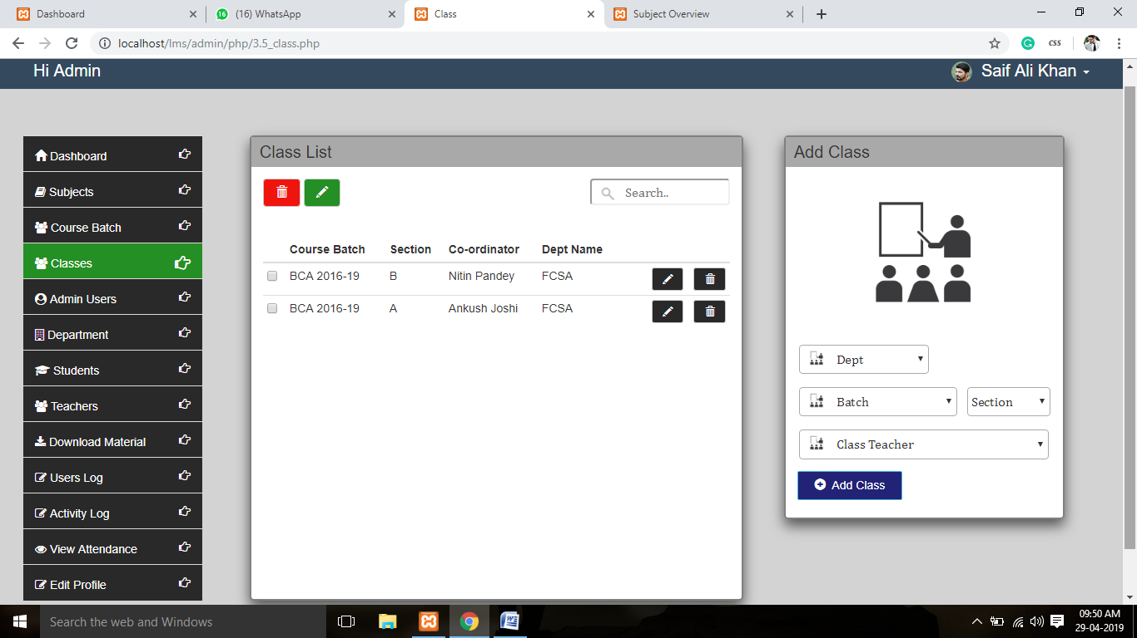

**Admin Users – Manage Admin Users**

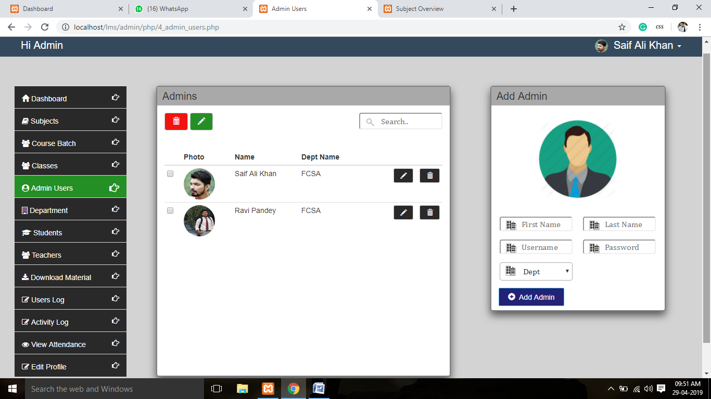

**Department – Manage Departments**

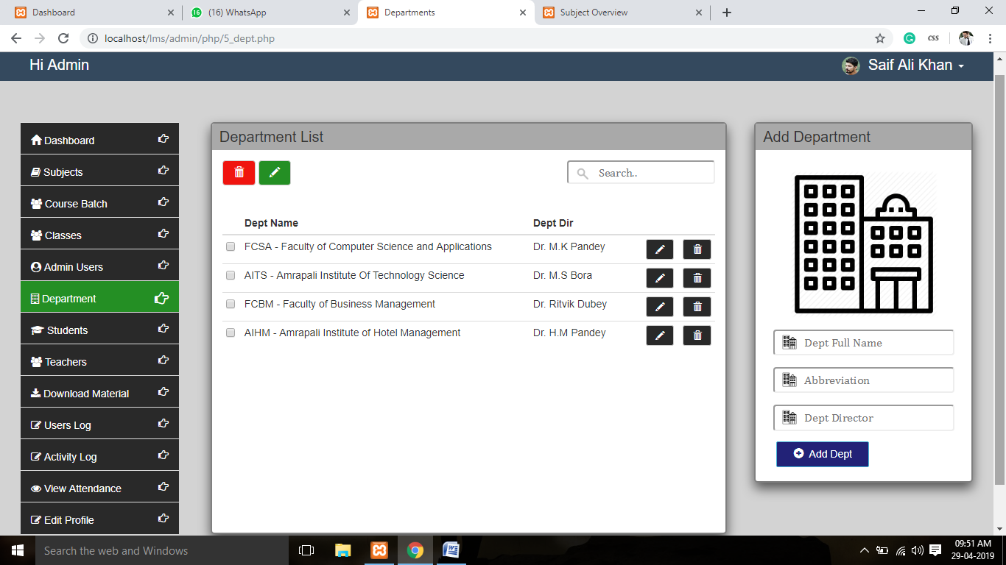

**Students- Manage Students**

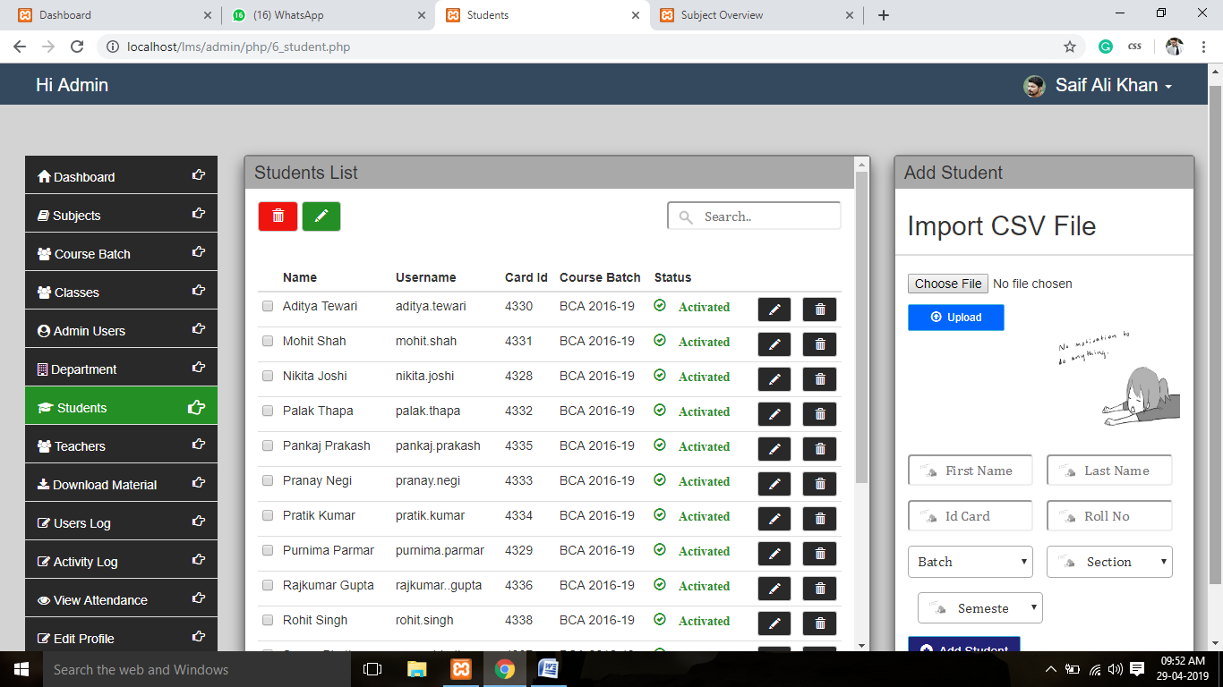

**Teachers – Manage Teachers**

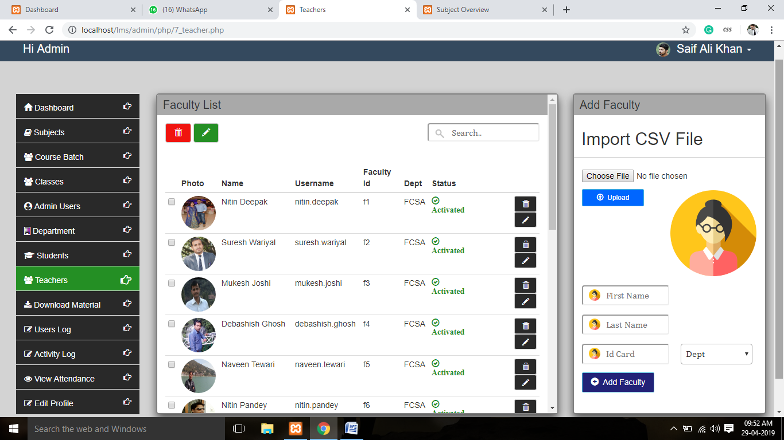

**Downloadable Material – Monitor Download Material**

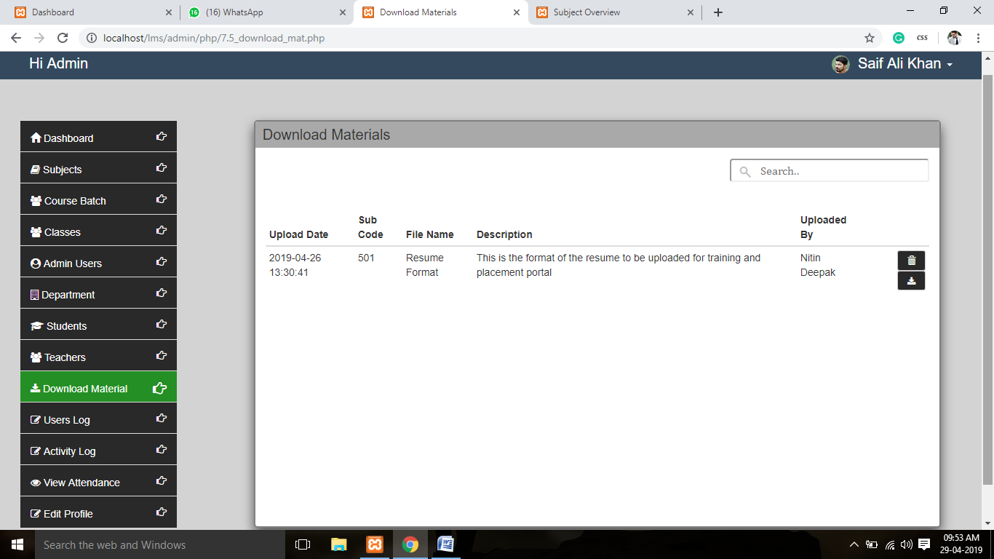

**User Log – Monitor Users log**

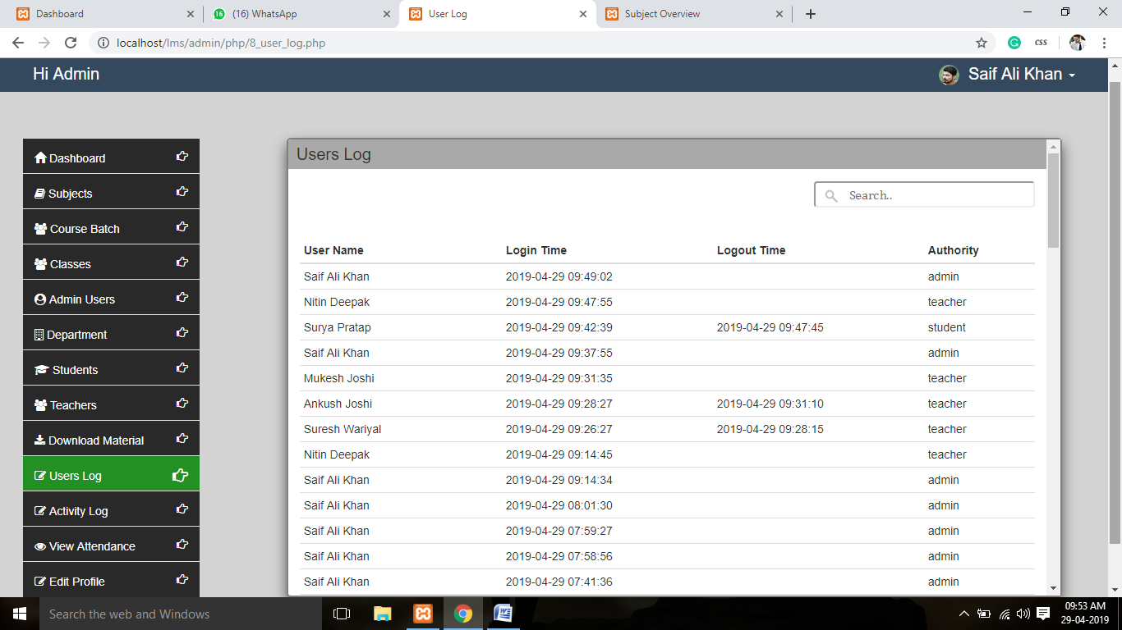

**Activity Log – Monitor Activity Of Users**

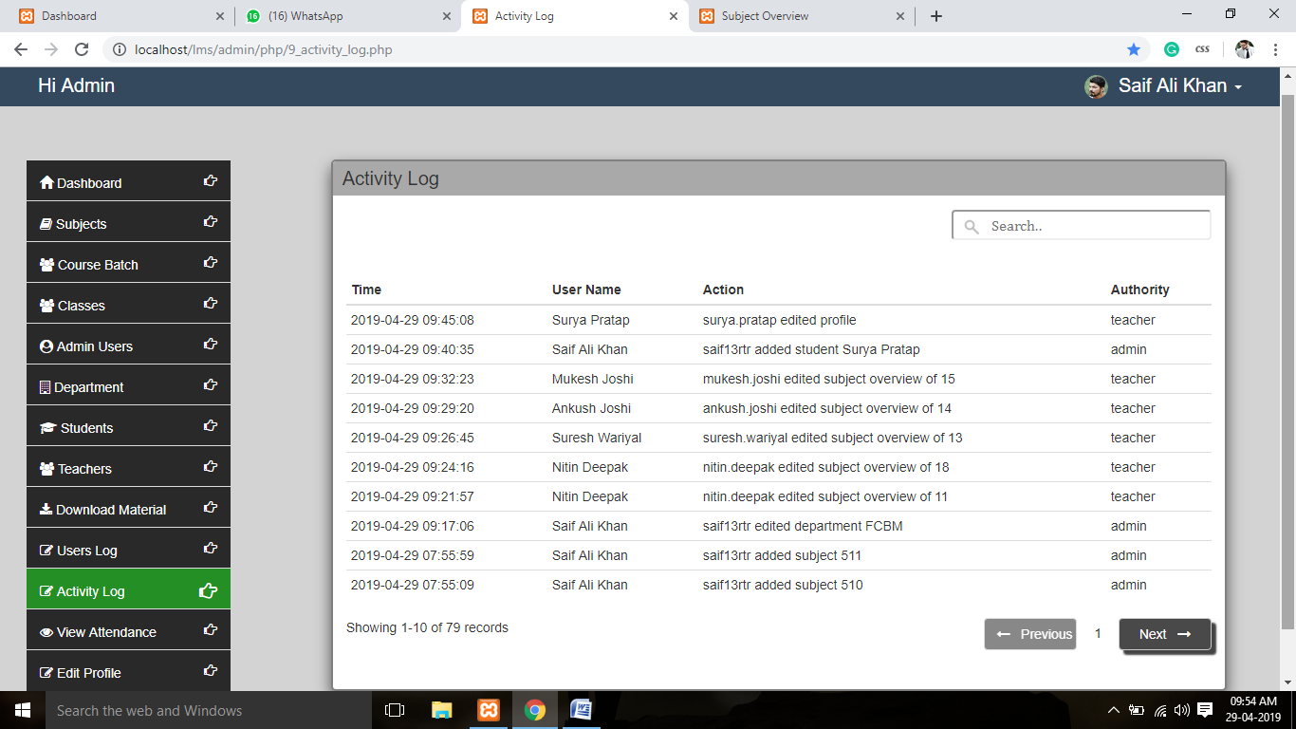

**View Attendance**

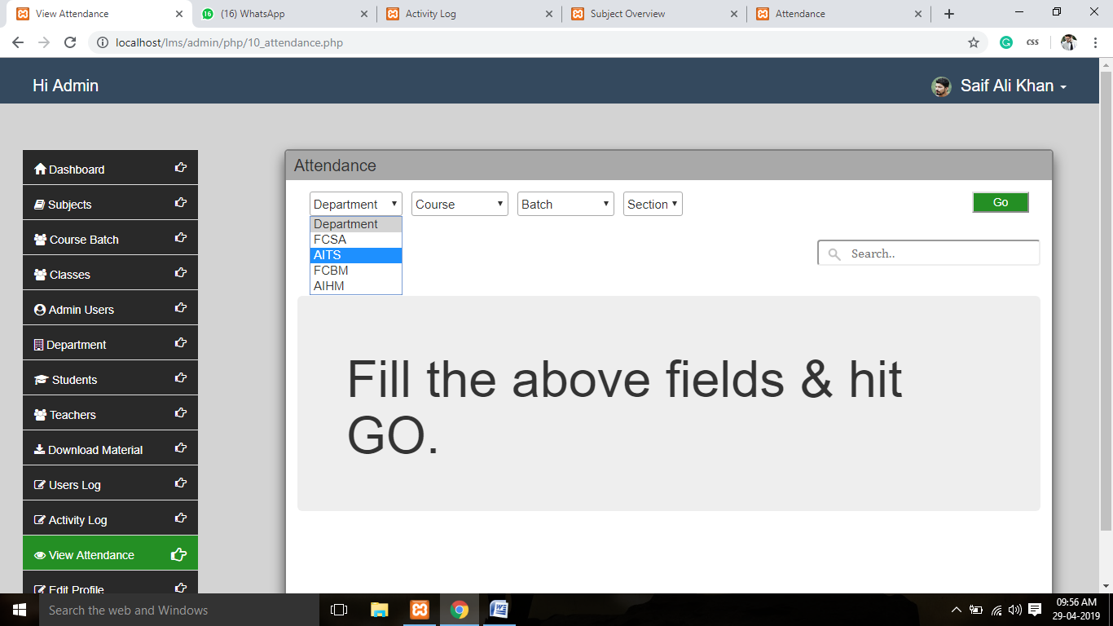

**View Attendance – Of a class**

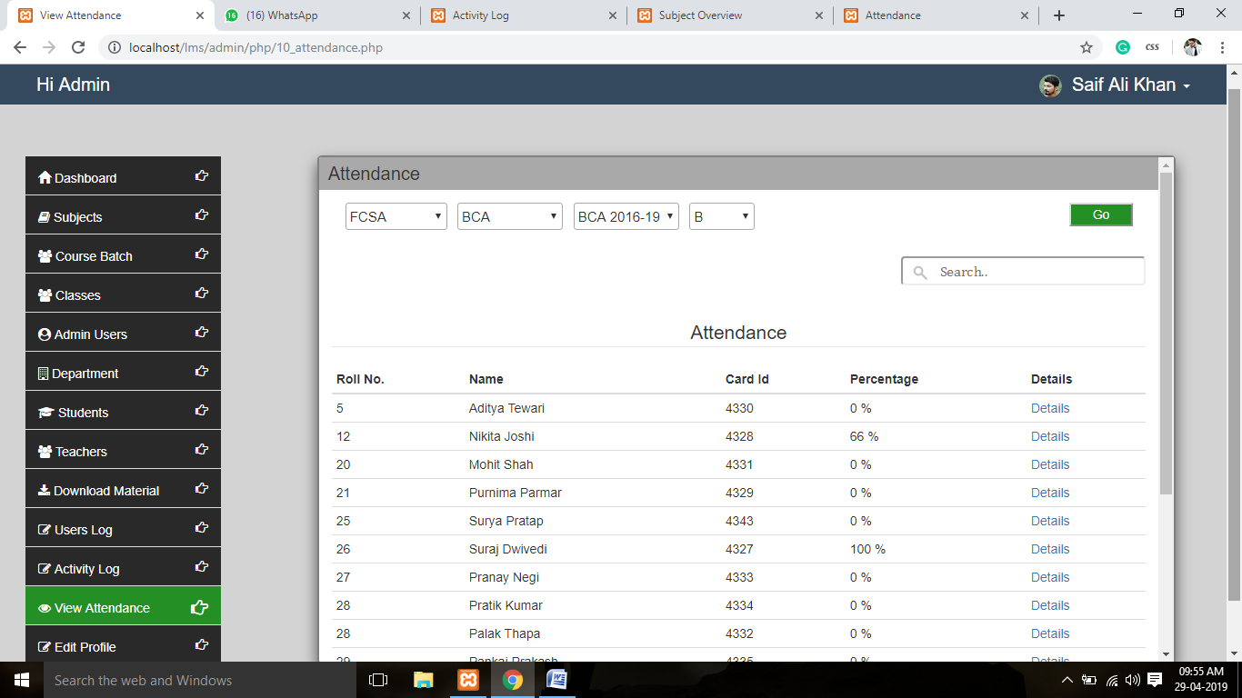

**View Attendance of an individual student**

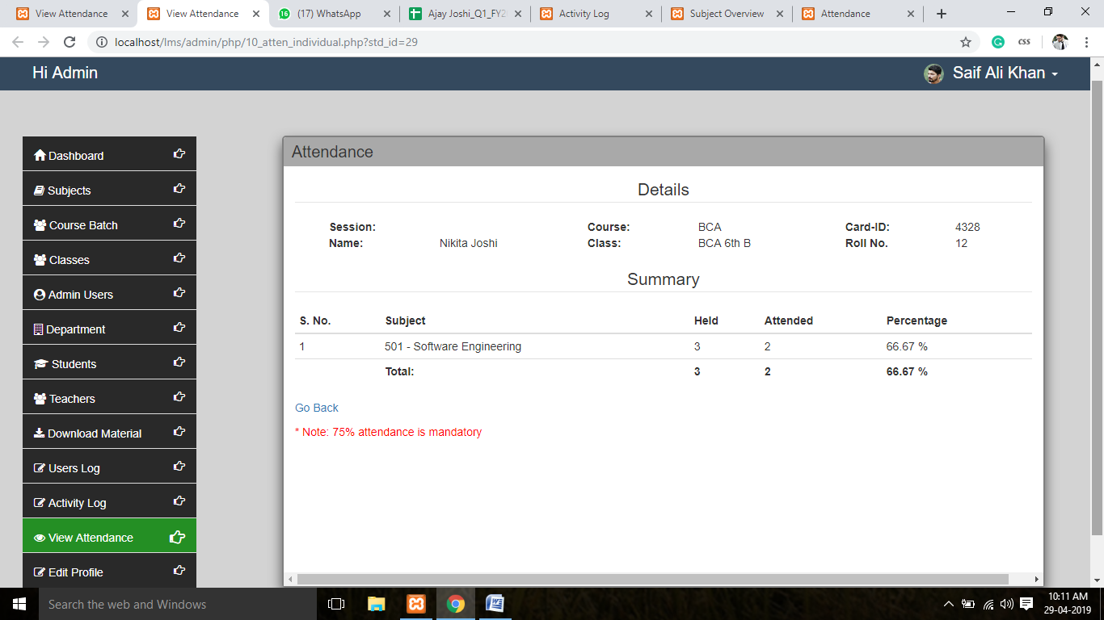

**Edit profile- Simple & Friendly Interface**

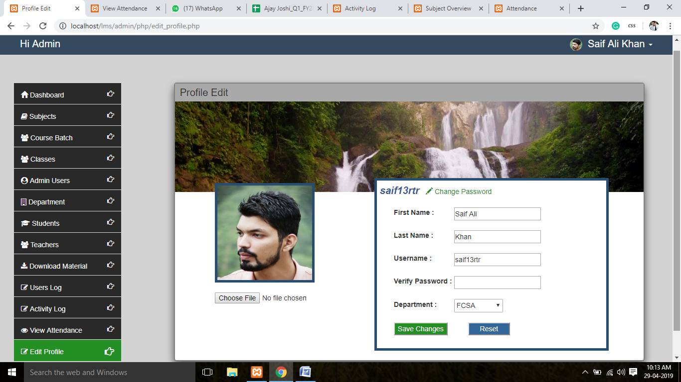

**Teacher Dashboard – Displays Student List**

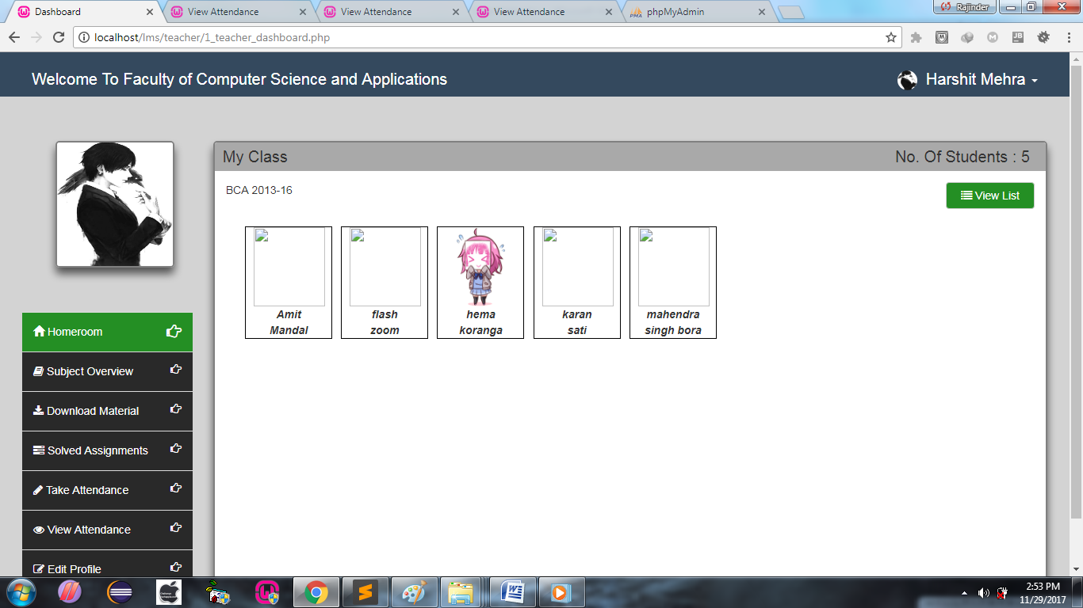

**Homeroom – Displays Student List In Detail**

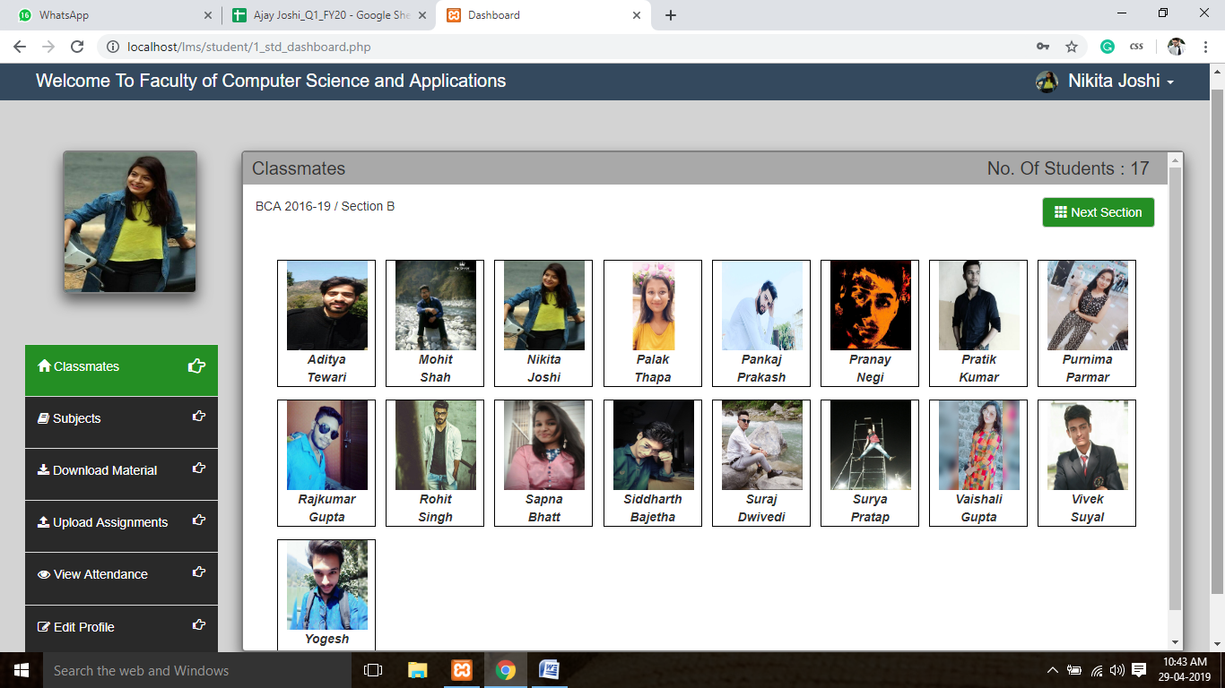

**Subject Overview – Managing their Subject’s Overview**

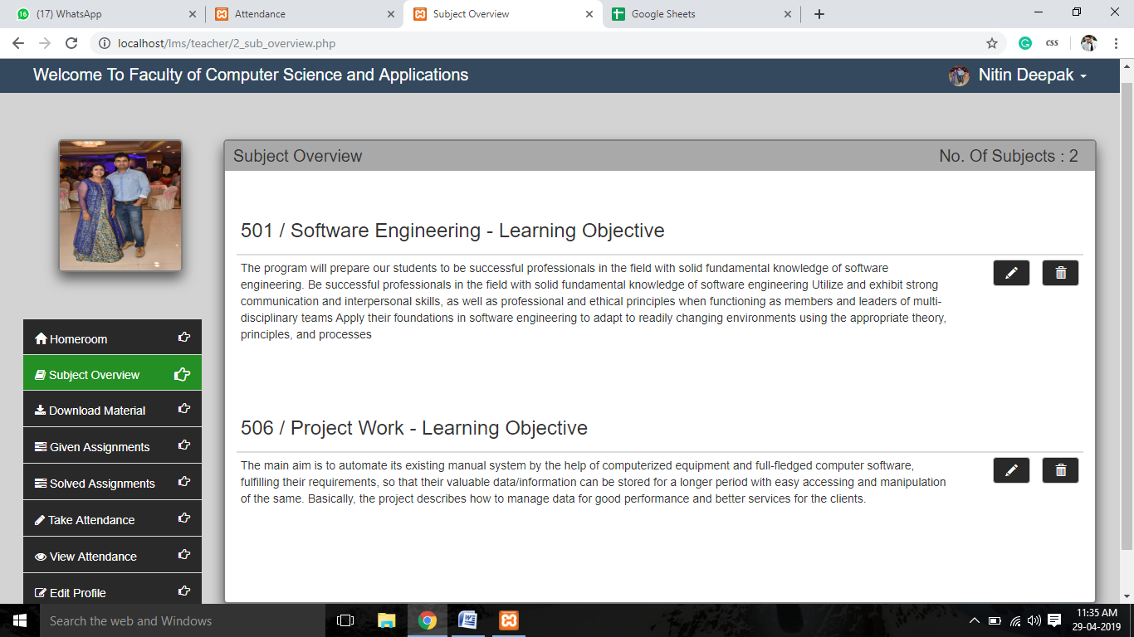

**Download Material – Displays their subject’s download material**

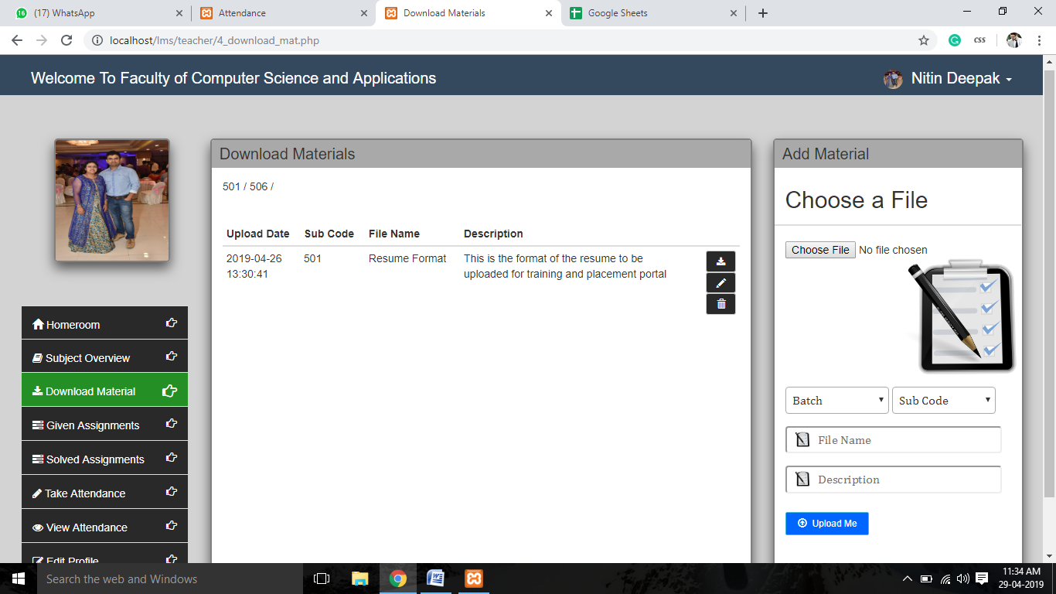

**Assignment Solutions – View Student’s submitted assignment**

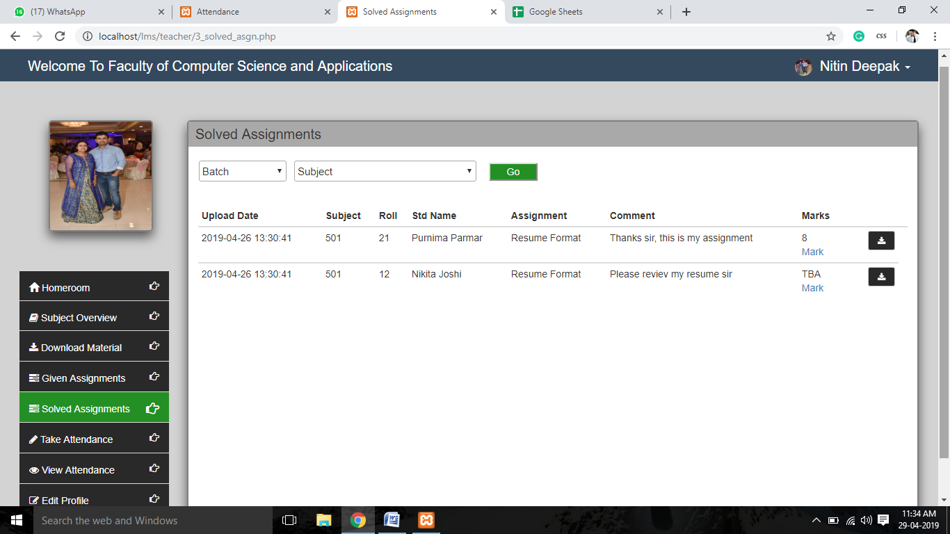

**Assignments Solution-Mark them on the basis of their performance**

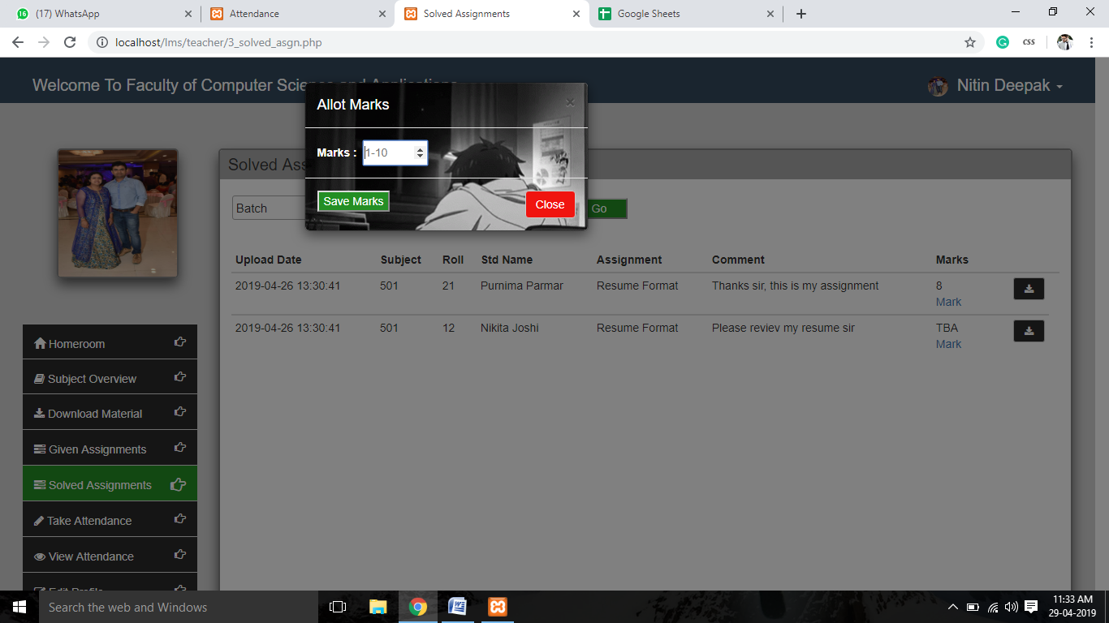

**Take Attendance**

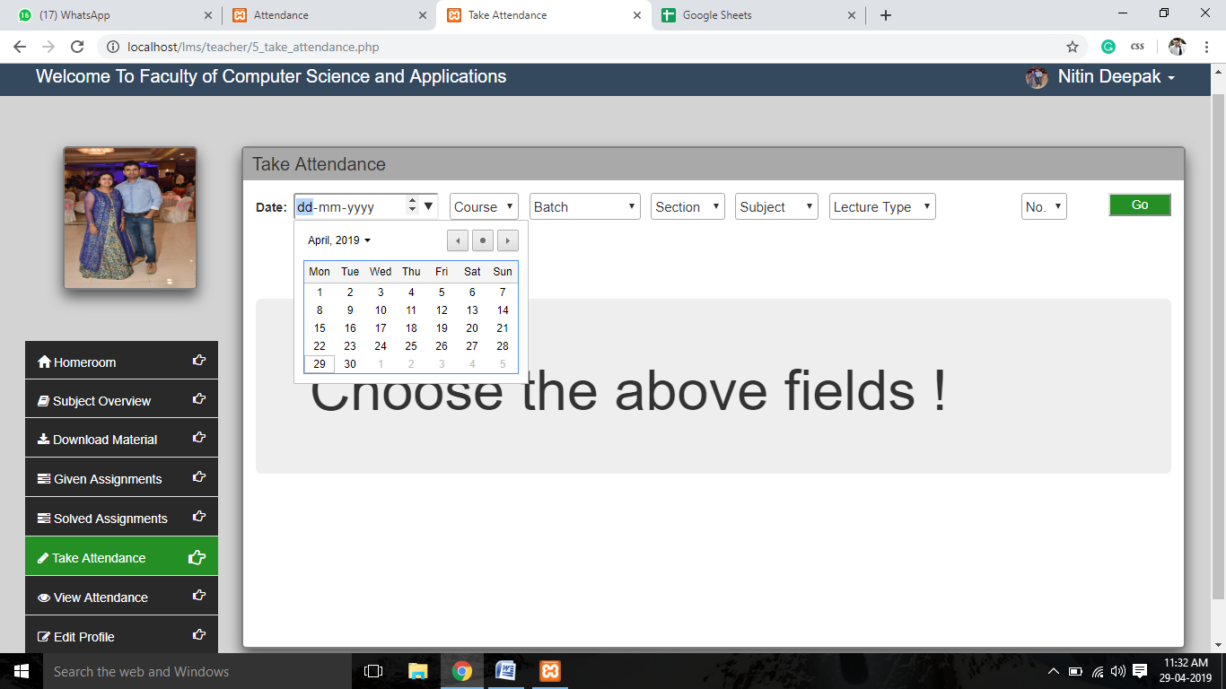

**Take Attendance**

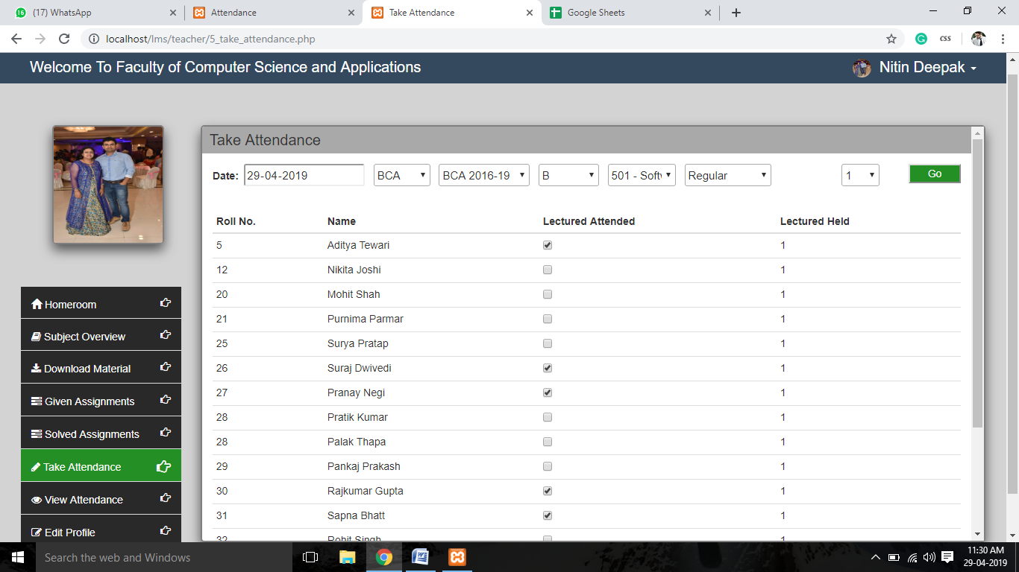

**View Attendance- Of their class**

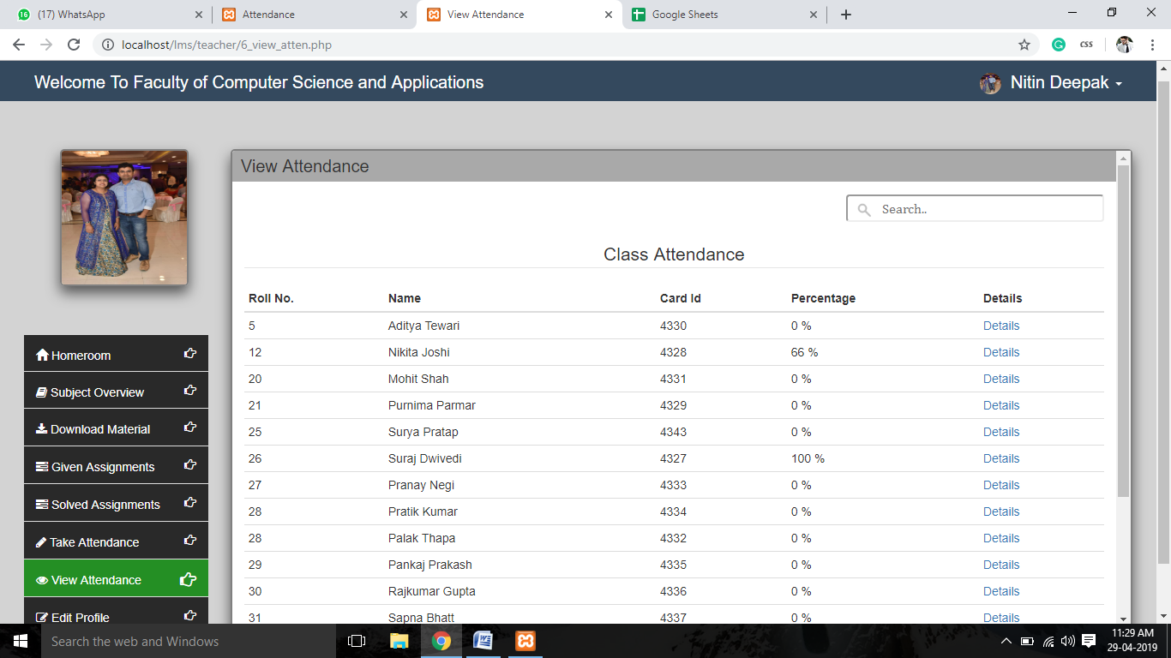

**View Attendance- Get details of a particular student**

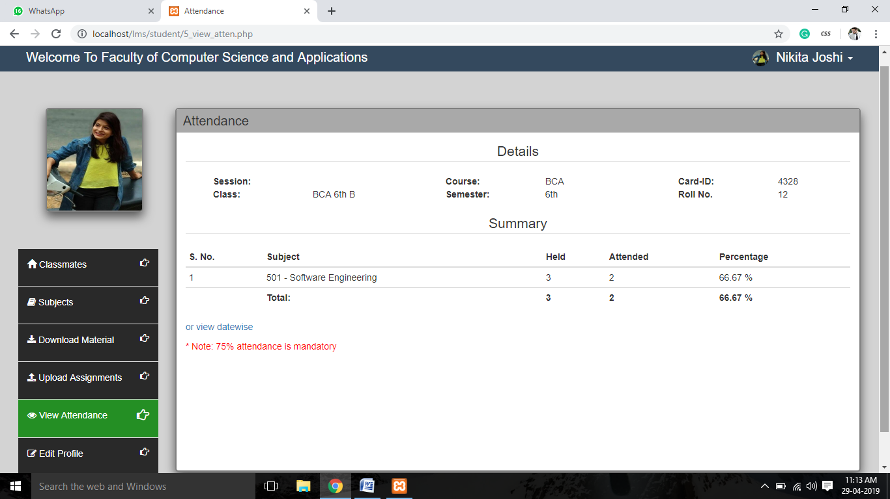

**E**d**it Profile**

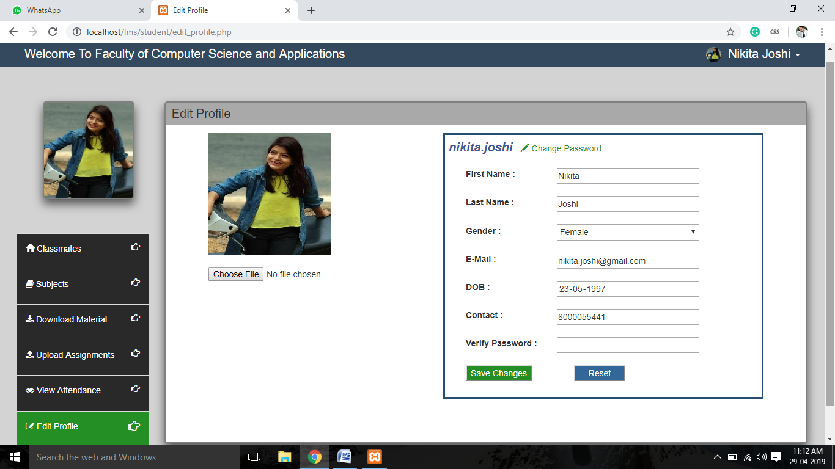

**Student Dashboard- Displays classmates list**

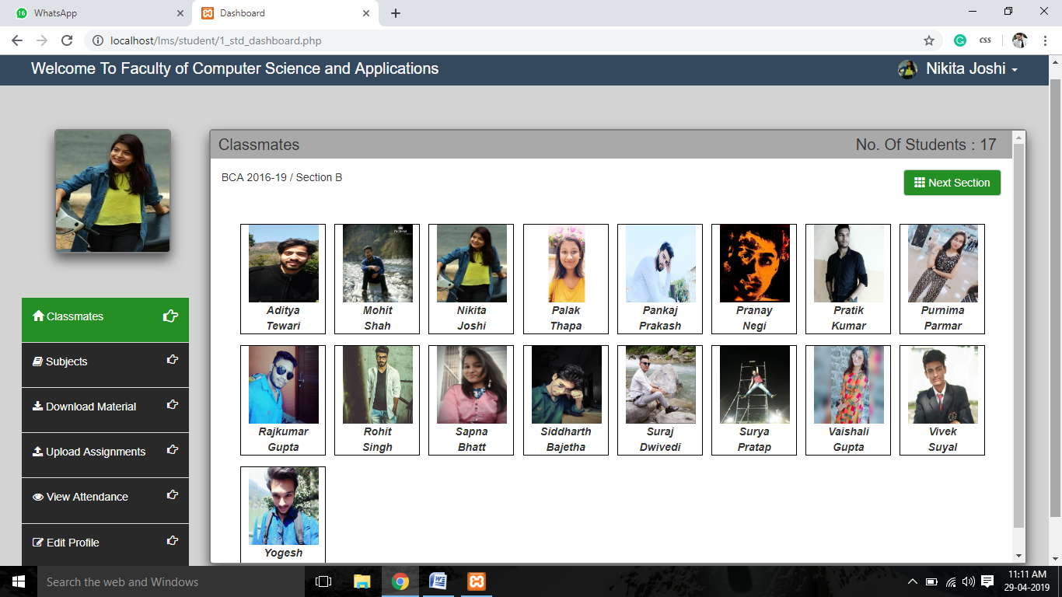

**Subjects**

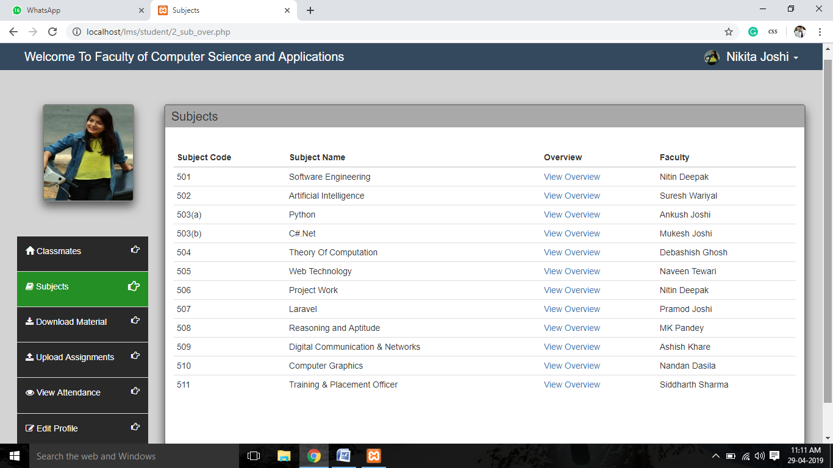

**Downloads Materials**

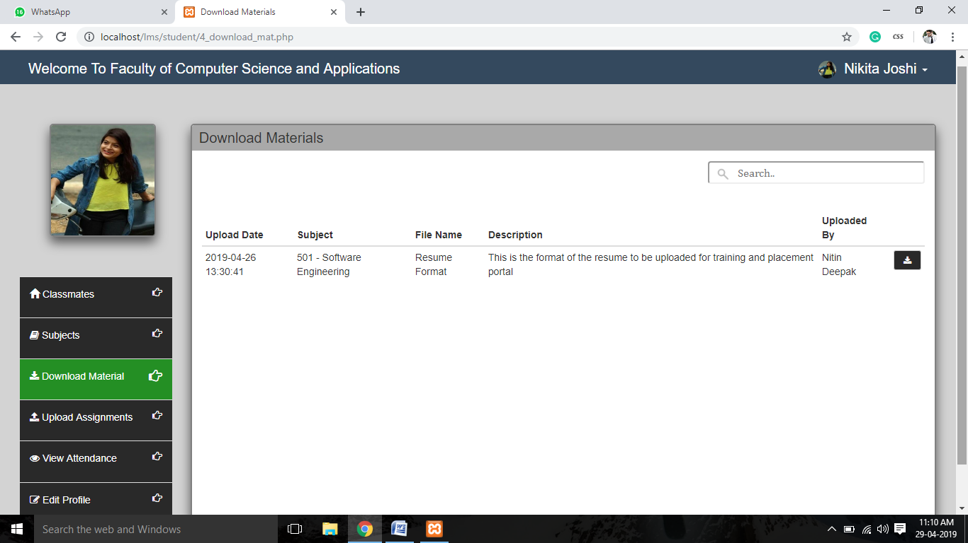

**Submit Assignments**

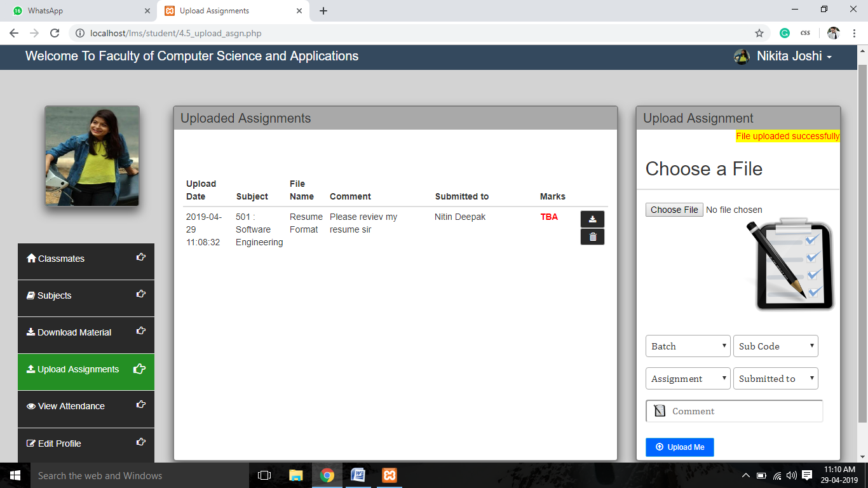

**View Attendance**

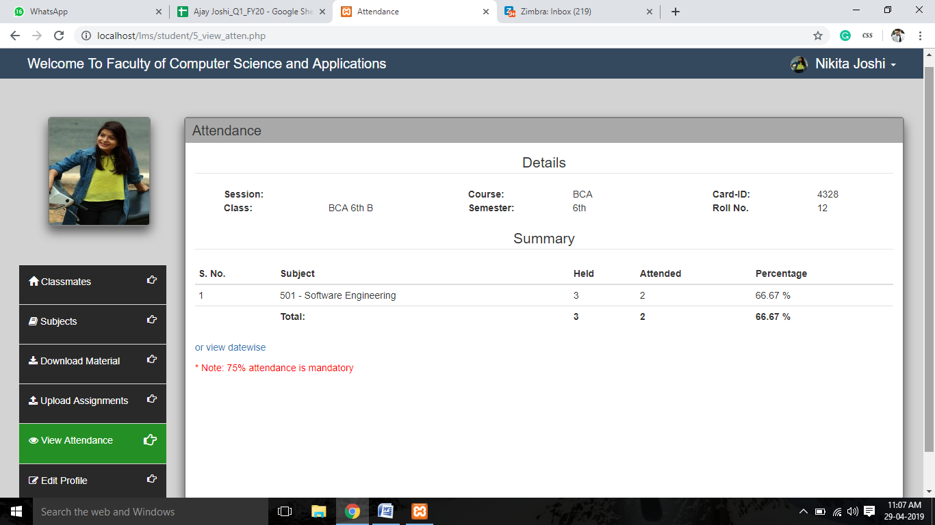

**View Attendance- Datewise**

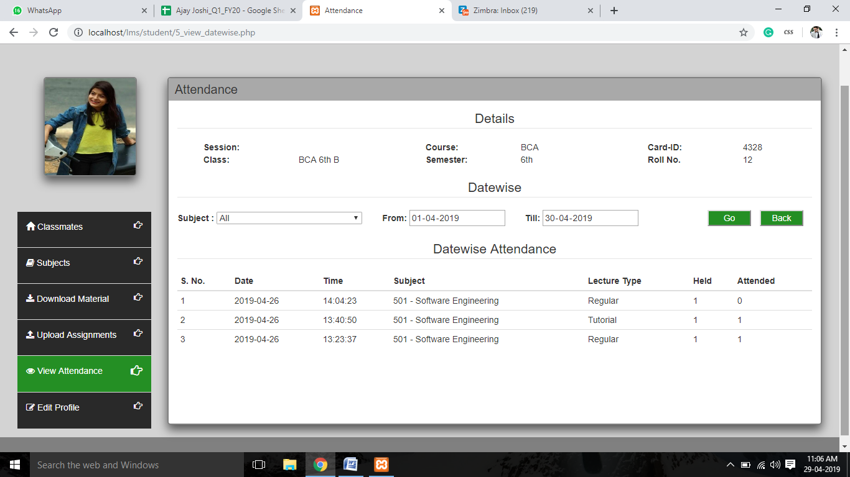

**Edit Profile**

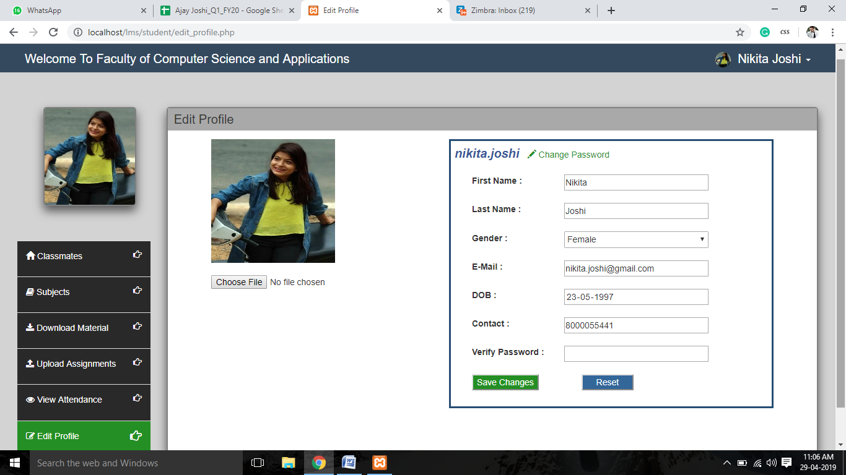

**5. CONCLUSION OF THE PROJECT LEARNING MANAGEMENT SYSTEM**

Our project is only a humble venture to satisfy the needs to manage the project work. Several user friendly coding have also adopted. This package shall prove to be a poIrful package in satisfying all the requirements of the organization. The objective of software planning is to provide a framework that enables the manager to make reasonable estimates made within a limited time frame at the beginning of the software project and should be updated regularly as the project progresses.

**Effort has been made on following points :-**

* A description of the background and context of the project and its relation to work is already done in the area.
* The description of purpose, scope and applicability.
* I designed user interface and security issues related to system.
* Made statements of the aims and objectives of the project.
* Finally the system implemented and tested according to test cases.

1. **FUTURE SCOPE OF LEARNING MANAGEMENT SYSTEM**

I have left all the options open so that if there is any other future requirement in the system by the user for the enhancement of the system then it is possible to implement them. In a nutshell, it can be summarized that the future scope of the project circles around maintaining information regarding:

* I will provide an institutional event calendar.
* I can give more advance functionalities for E- Learning Management System
* I will host the platform on online servers to make it accessible worldwide.
* I will conduct online quiz.
* Implement the backup mechanism for taking backup of codebase and database on regular basis on different servers.

The above mentioned points are the enhancements which can be done to increase the applicability and usage of this project. Enhancements can be done to maintain all the course, student, faculty, assignment, course type.

I hope that the project will serve its purpose for which it is developed there by underlining success of process.

1. **LIMITATIONS OF PROJECT ON LEARNING MANAGEMENT SYSTEM**

Although I have put our best efforts to make the software flexible, easy to operate but limitations cannot be ruled out even by us. Though the software presents a broad range of options to its users some intricate options could not be covered in it; partly because of logistics and partly due to lack to sophistication. Paucity of time was also a major constraint, thus it was not possible to make the software foolproof and dynamic.

Considerable efforts have been made to make software easy to operate even for the people not related to the field of computers.

1. **REFERENCES**

[1]. <http://www.onlinegurujee.in/prajput/>

[2]. <http://www.onlinegurujee.in/drnaveentewari/>

[3]. [http://www.onlinegurujee.in/nitindeepak/](http://www.onlinegurujee.in/prajput/)

[4]. <http://www.tutorialspoint.com/php>/

[5]. <http://www.w3schools.com/html/>

[6]. <http://www.w3schools.com/css/>

[7]. <http://www.stackoverflow.com/>

[8]. <http://www.codecademy.com/javasript/>